

**A data lake foundational lab using Glue, Athena and QuickSight**

Version 1.1

December 2018

Authored by

Asim Kumar Sasmal, Senior Big Data Consultant, [sasasim@amazon.com](mailto:sasasim@amazon.com)

Updated by

David Sulkin [dave.sulkin@parivedasolutions.com](mailto:dave.sulkin@parivedasolutions.com)

Angela Wang [angelaw@amazon.com](mailto:angelaw@amazon.com)

Table of Contents

Purpose 1

Target Audience 1

Sample Dataset 1

High Level Process Flow 3

AWS Glue 4

Glue Data Catalog 4

Create Catalog Database 4

Discover Data using Crawler 5

Edit Table Schema 12

Amazon Athena 16

Query using Athena 16

Glue ETL - Transform Data - CSV to Parquet 20

Using Glue ETL Autogenerated Spark Code 20

Using Glue ETL Custom Spark Code 26

Crawl and Create Parquet Tables 31

Rerun Queries using Athena (using Parquet tables) 32

Athena Query Runtime Comparison for CSV and Parquet 34

Amazon QuickSight 36

Visualizing using QuickSight 36

Summary 43

# Purpose

The purpose of this artifact is a quick hands-on Data Lake foundation lab using AWS Glue (Catalog and ETL service), Amazon Athena and Amazon QuickSight.

# Target Audience

This document is intended for AWS Professional Services consultants, Solution Architects, AWS Partners, Customers, and anyone else who are interested to get some quick hands on experience of AWS Glue (Catalog and ETL), Amazon Athena and Amazon QuickSight using one of the publicly available AWS sample datasets.

# Sample Dataset

The sample dataset chosen for this tutorial is a Star Schema Benchmark (SSB) dataset which has been copied and stored in a S3 bucket specific for each user and can be found at the following location:

* S3://united-datalake-workshop-<initials-suffix>

Each S3 bucket will contain the 4 folders show below:



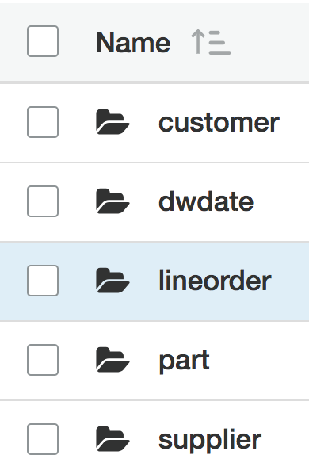

**To make sure you are interacting with the right services, your AWS region should be set to Northern Virginia (US-East-1) during the entire lab**

The dataset consists of five tables (one fact table and four dimension tables) in a star schema as shown below.

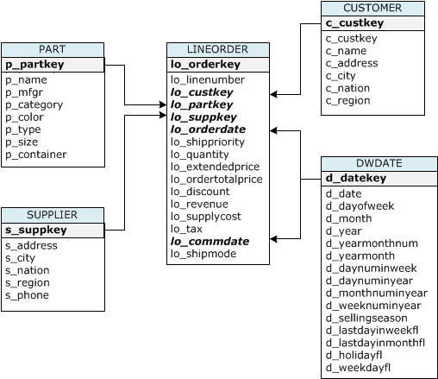

**Data Points**

* Total size for all the tables – 25.3 GiB
* CSV file format
* gzip compressed
* customer (dimension) – 1 file – 100.5 MiB
* dwdate (dimension) – 1 file – 24.6 KiB
* part (dimension) – 4 files – 33.2 MiB
* supplier (dimension) – 1 file – 32.5 MiB
* lineorder (fact) – 8 files – 24.8 GiB

You can navigate to the S3 console to review the contents of your bucket. To do so:

* Log in to the [AWS Console](https://us-west-2.console.aws.amazon.com/console/home?region=us-west-2)
* Type S3 in the **Find Services** section
* Click on the link to S3 Console
* Click into your bucket **united-datalake-workshop-<your-name>**

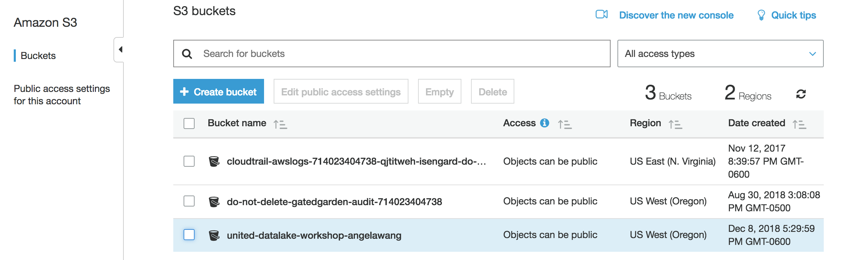

# High Level Process Flow

Here is the high-level process flow of the lab.



**For this lab, we will not be working with Redshift or Redshift Spectrum**

# AWS Glue

AWS Glue is a fully managed **data catalog and ETL** (extract -> transform -> load) service that simplifies and automates the difficult and time-consuming tasks of data discovery, conversion, and job scheduling. AWS Glue crawls your data sources and constructs a data catalog using pre-built classifiers for popular data formats and data types, including CSV, Apache Parquet, JSON, and many more.

Because AWS Glue is integrated with Amazon S3, Amazon RDS, Amazon Athena—the core components of a modern data architecture—it works seamlessly to orchestrate the movement and management of your data.

The AWS Glue Data Catalog is compatible with Apache Hive Metastore and supports popular tools such as Hive, Presto, Apache Spark, and Apache Pig. It also integrates directly with Amazon Athena, Amazon EMR, and Amazon Redshift Spectrum.

In addition, the AWS Glue Data Catalog features the following extensions for ease-of-use and data-management functionality:

* Discover data with search
* Identify and parse files with classification
* Manage changing schemas with versioning

For more information, see the [AWS Glue product details](https://aws.amazon.com/glue/details/).

# Glue Data Catalog

## Create Catalog Database

Navigate to AWS Glue console by clicking on **Services** on the top navigation bar and type in “Glue”

On the left hand side bar, click on **Databases**. Create a new database called “gz-glue-db-<initials-suffix>”. Be sure to use the initials-suffix that was provided by the email you received with AWS login information.

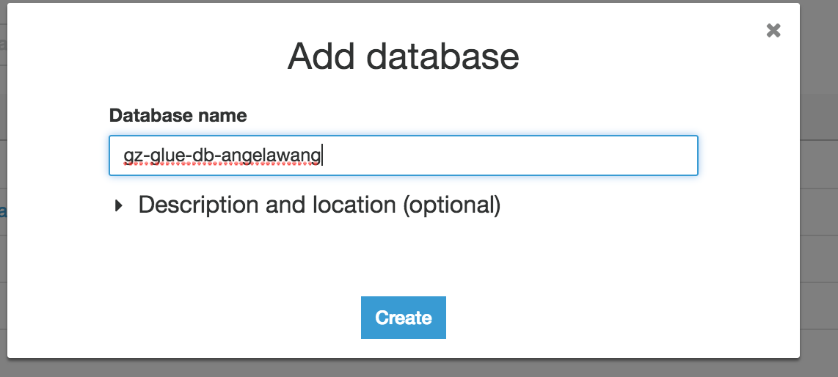

Here is the database you just created.

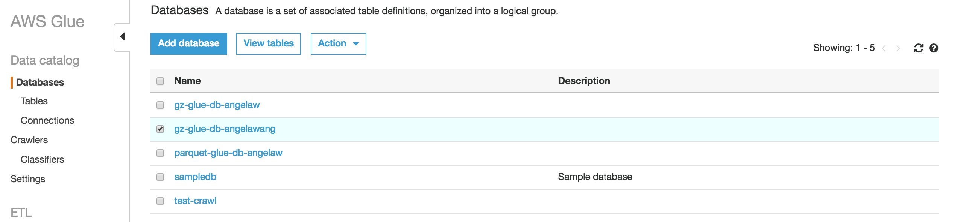

## Discover Data using Crawler

You can either create a crawler job per table in the SSB dataset or you can create one crawler job for all the tables. Latter is preferred to avoid having too many crawlers. Once the crawler is created, run the crawler to create the external tables in the catalog database.

Let’s navigate to “Crawlers” on the Glue console and click on “Add crawler” as shown below.

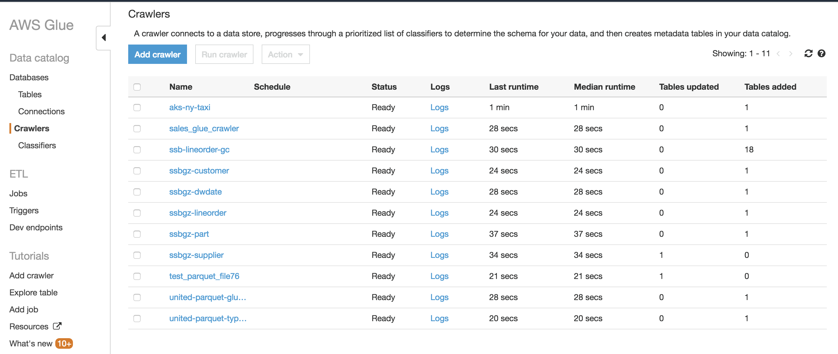

Create a crawler – “gz-<initials-suffix>” for all the tables as shown below

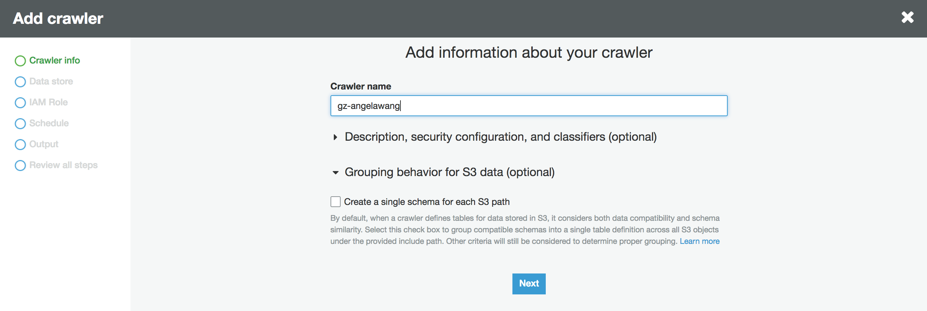

***Note***

*Crawler job name (*“gz-<initials-suffix>” *in this case) is not same as table name (a common confusion). Table name will be picked up automatically from the prefix/folder name from your S3 bucket/folder structure and you also have an option to attach a table name prefix if you would like.*

Click on “Next” to enter “Data store” details of the customer table in your S3 bucket.

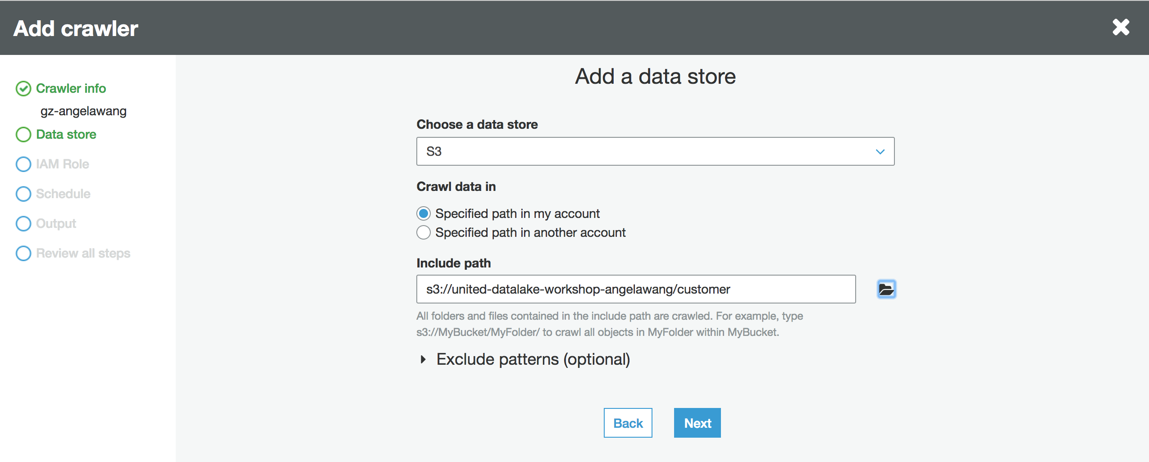

You can use the file selector to select the folder, or type in the S3 path directly:

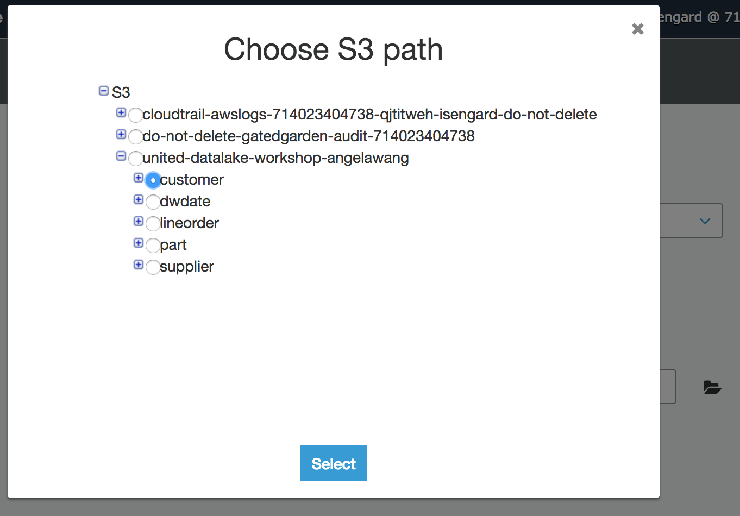

Click on “Next” to get to the “Add another data store” screen. For this tutorial, I am going to choose “Yes” and continue to add the remaining data stores in your S3 bucket – dwdate, lineorder, part, supplier.

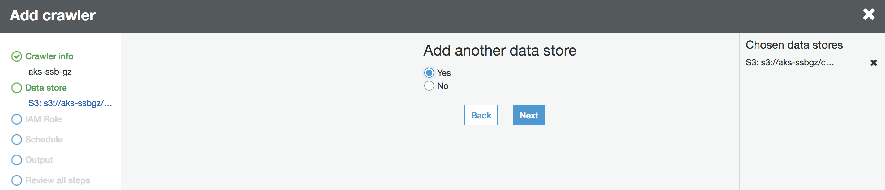

Click on “Next” and choose data store - “dwdate” as below

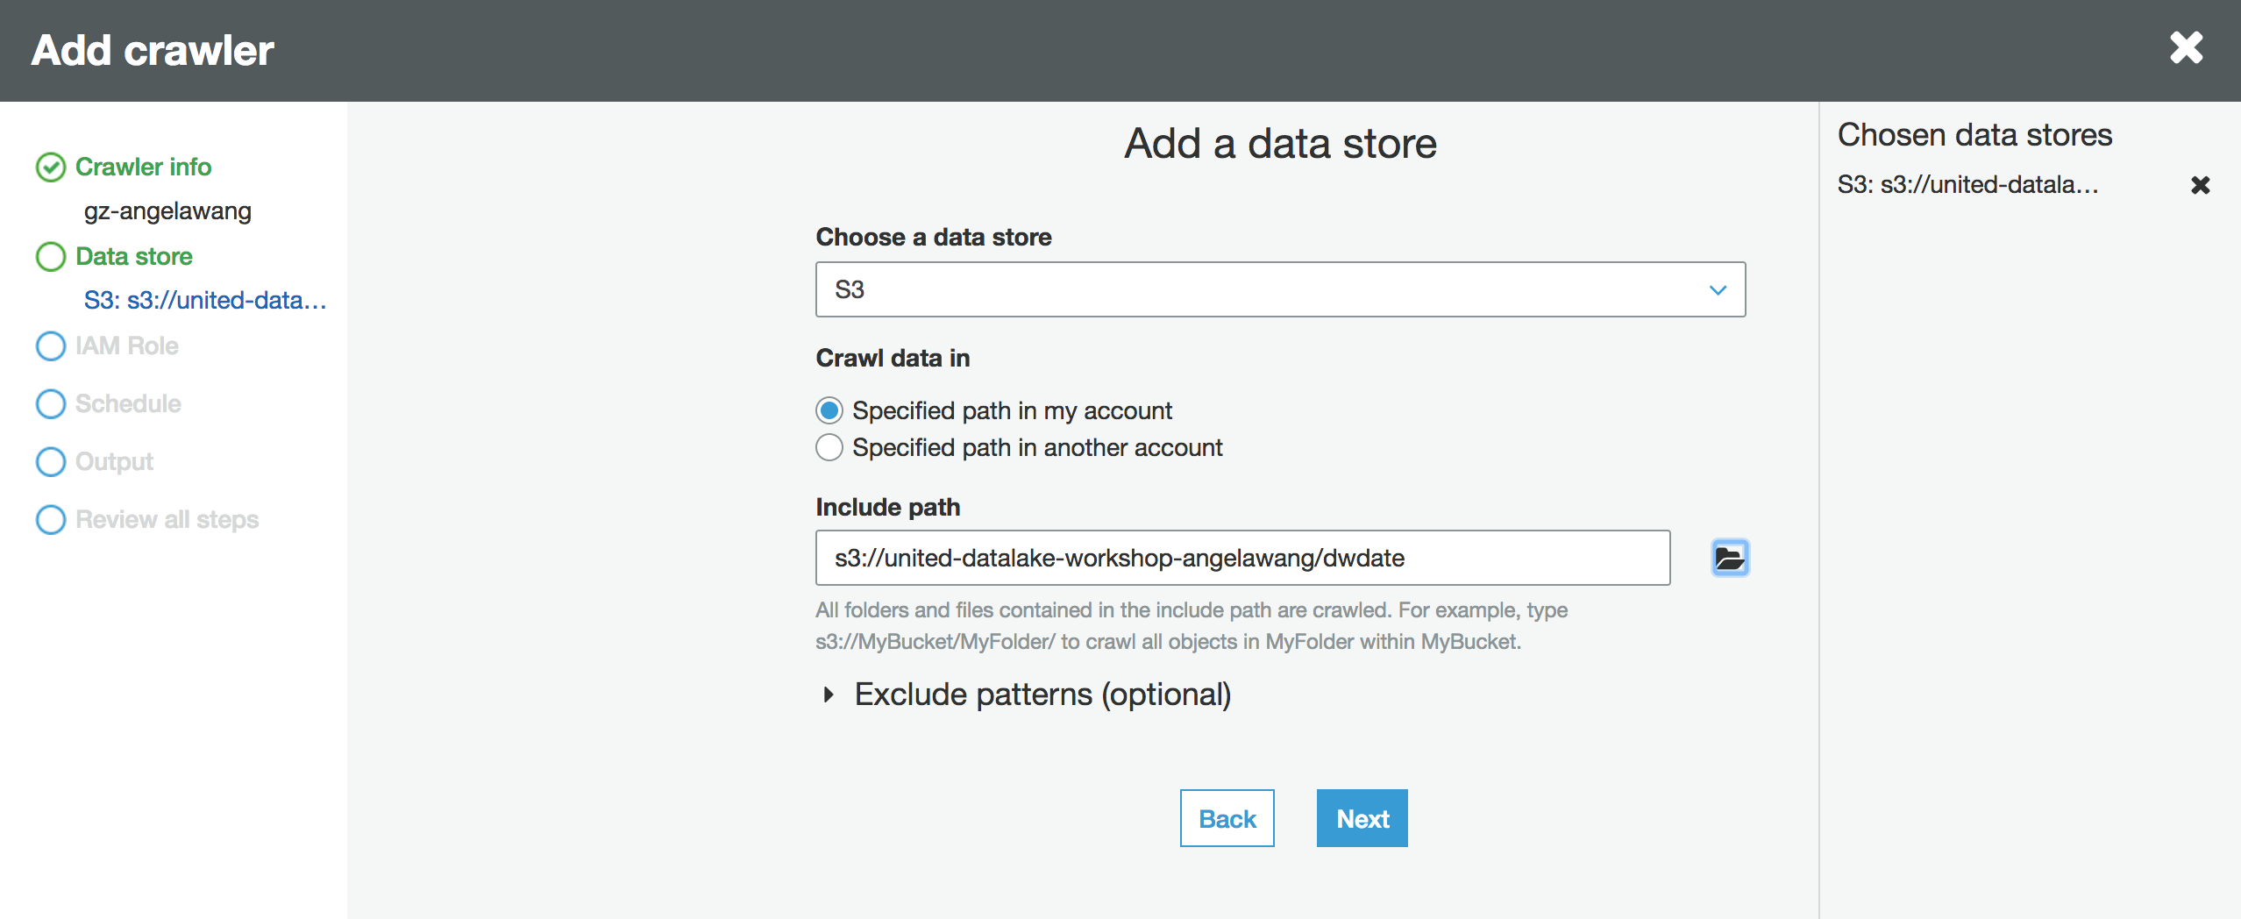

Click on “Next” and choose data store - “lineorder” as below

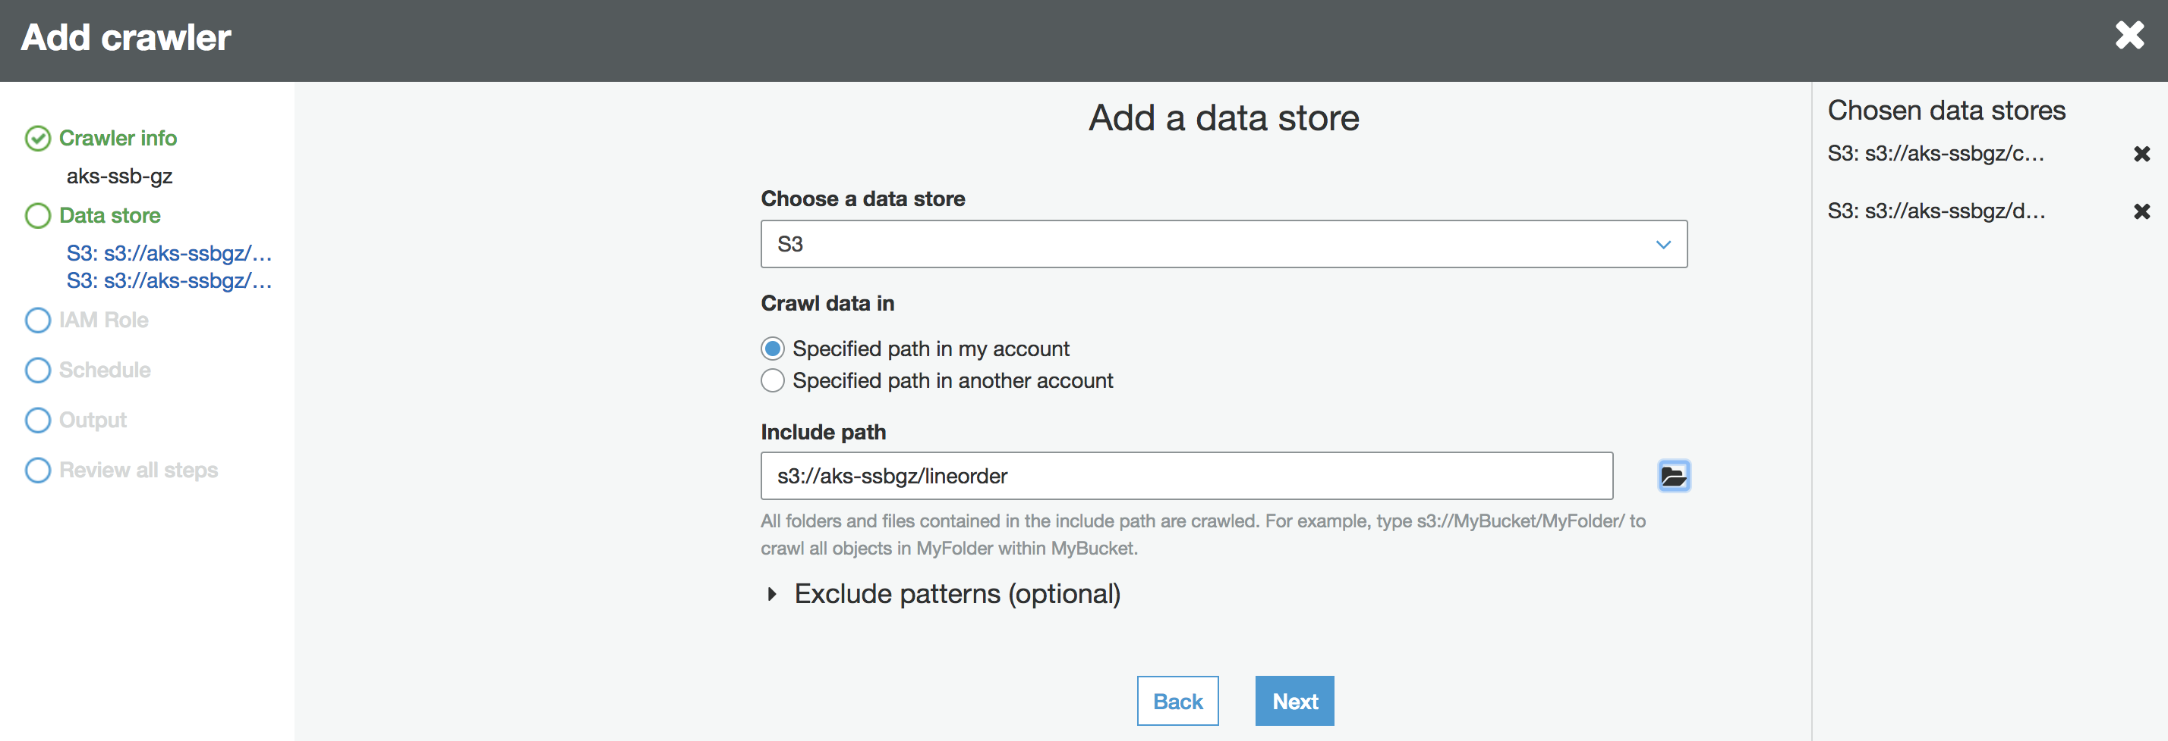

Click on “Next” to add data store - “part” as below

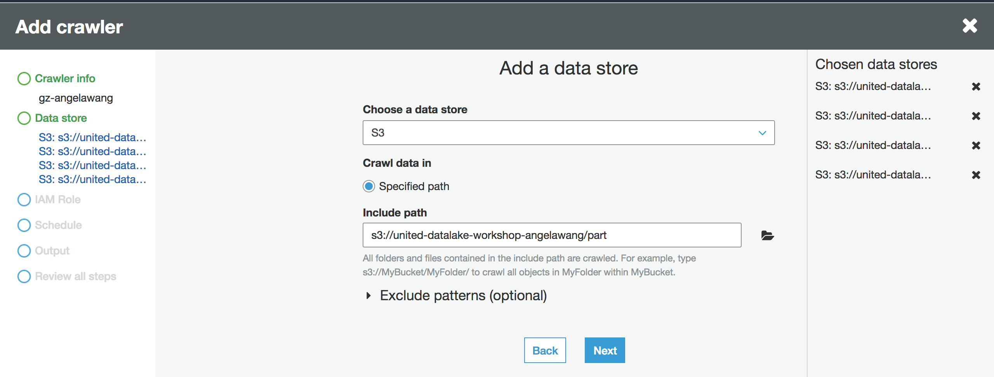

Click on “Next” and choose data store - “supplier” as below

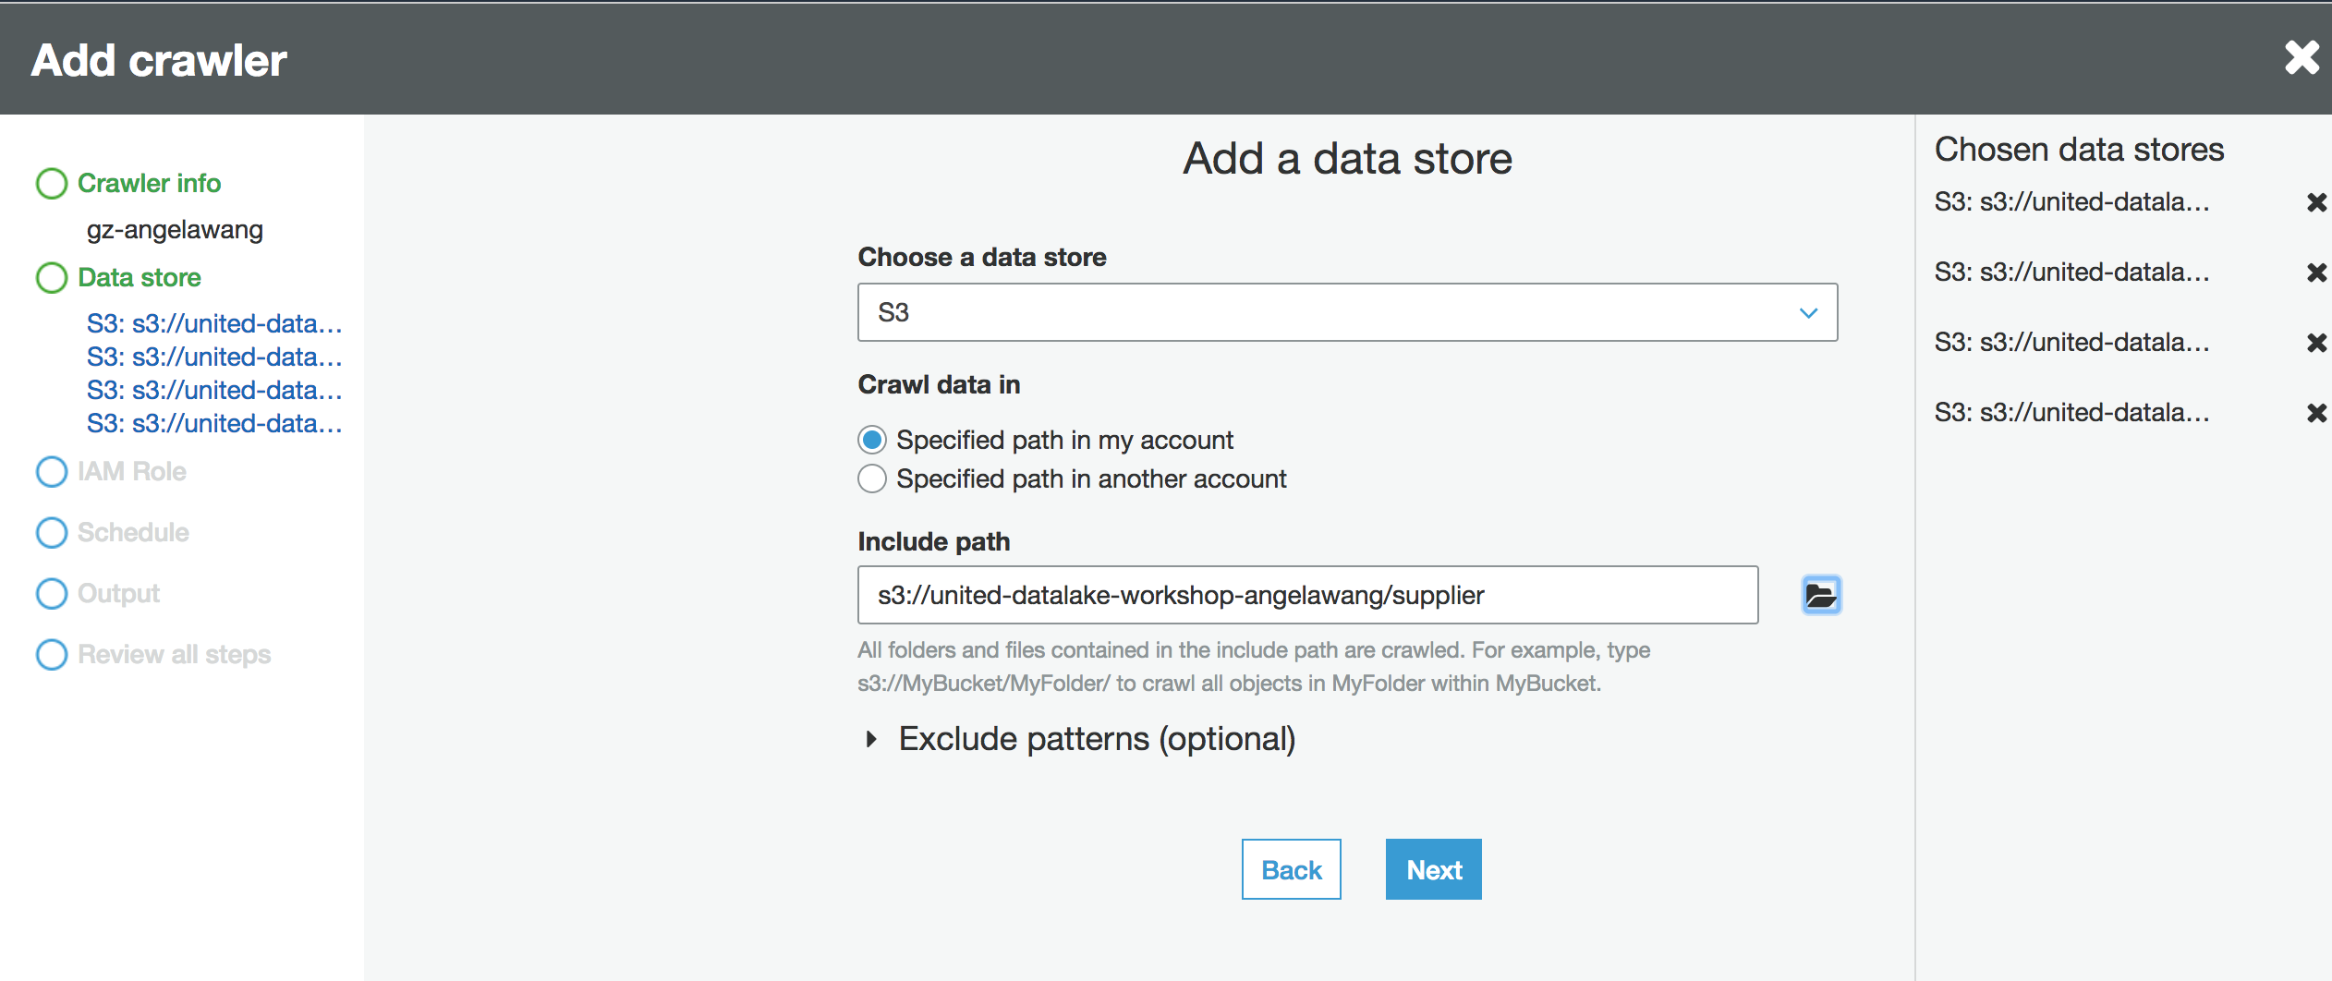

Now, since all the datastores are added, click on “Next” to get to the “Add another data store” screen and choose “No”.

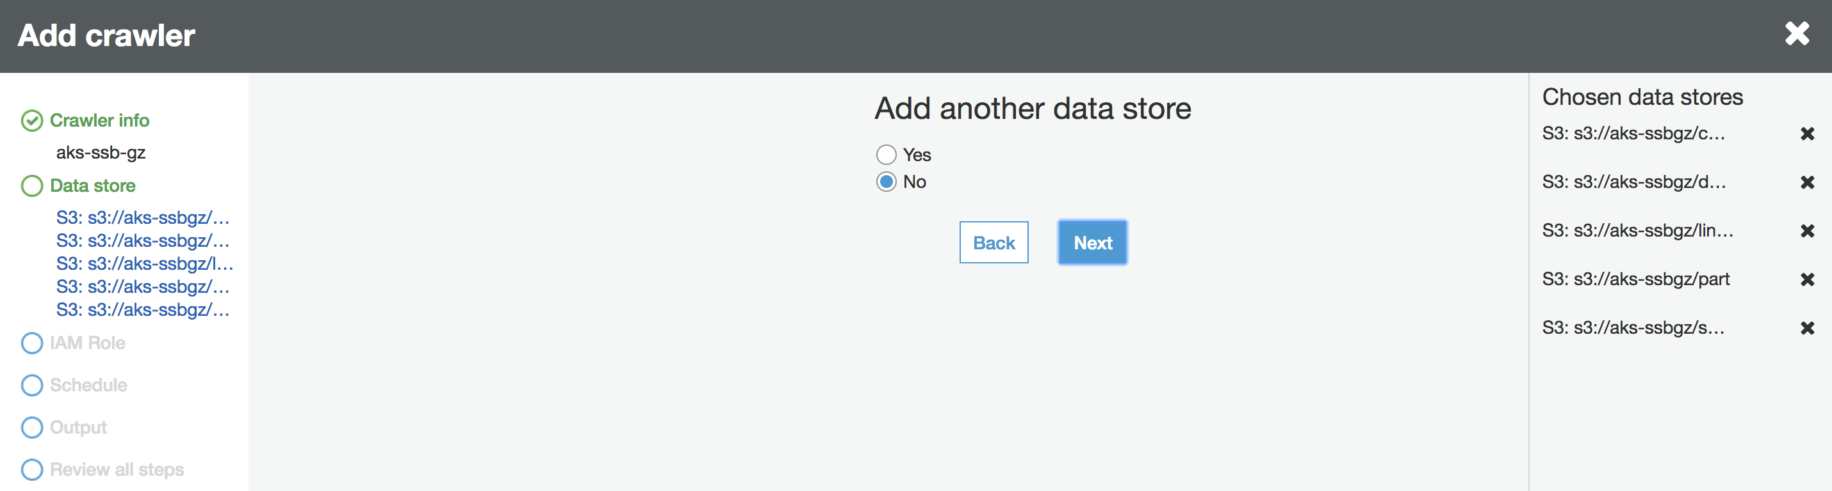

Click “Next” to choose the “IAM Role” for crawler to use. You can either create a new IAM role or choose an existing one. For this lab, choose the following **existing IAM role**:

* AWSGlueServiceRole-angelawang

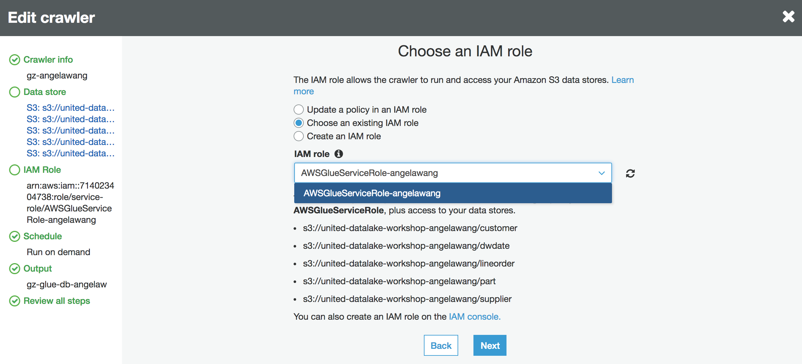

Click on “Next” to go to the “Schedule” page and choose the appropriate schedule you would like this crawler job to run. For this tutorial, I am choosing “Run on demand”.

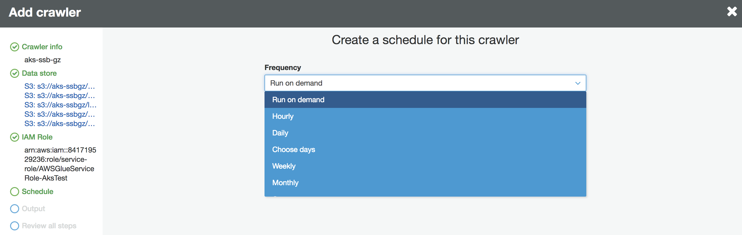

Click on “Next” to choose the Glue catalog database created earlier as the crawler output location.

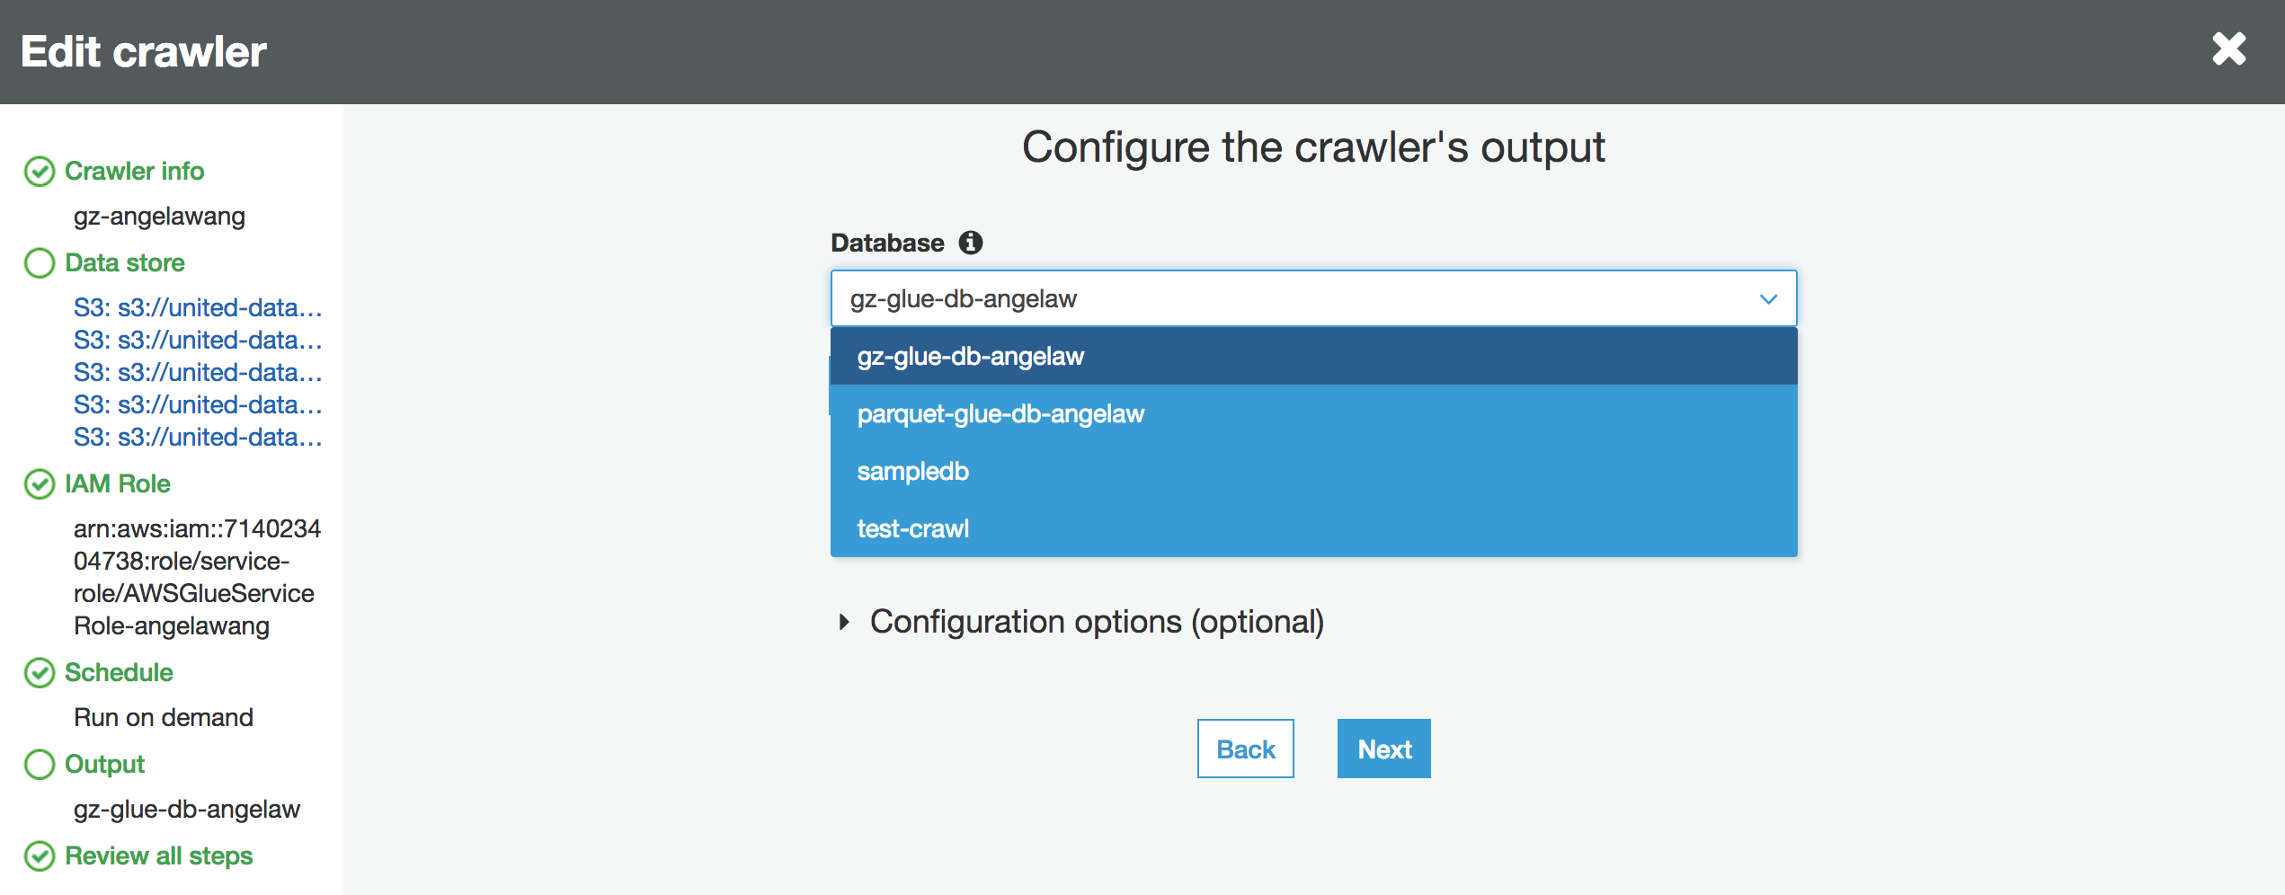

Click on “Next” to get to review page.

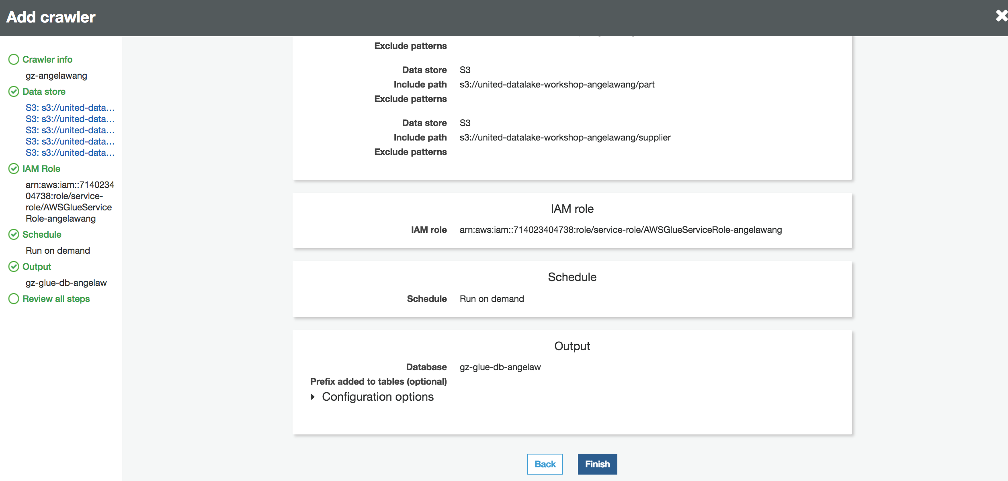

After reviewing the details, click on “Finish” to finish creating the crawler.

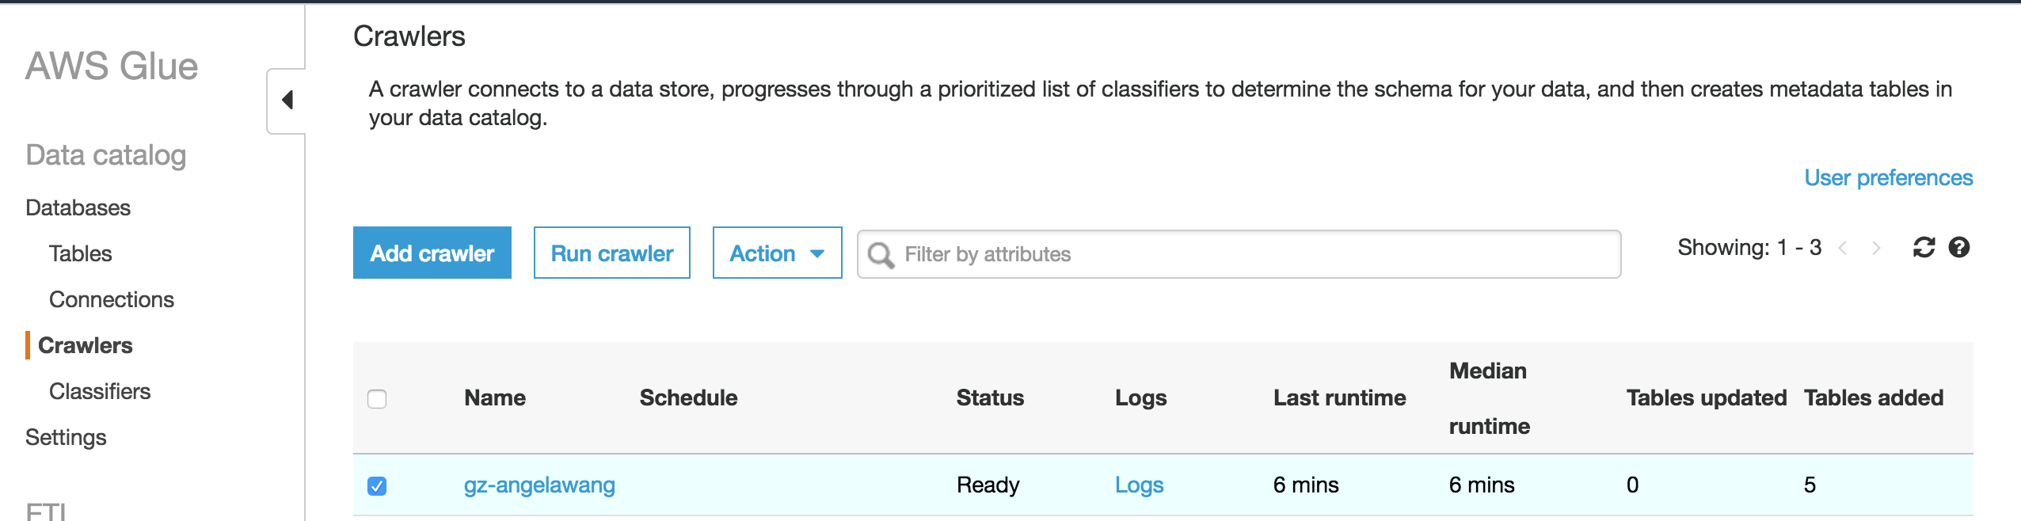

Now, let’s run the crawler job by selecting the job as below and click on “Run crawler”.



Wait for the job to complete when it is back to “Ready” status by going through the following

“Starting -> Stopping -> Ready”.

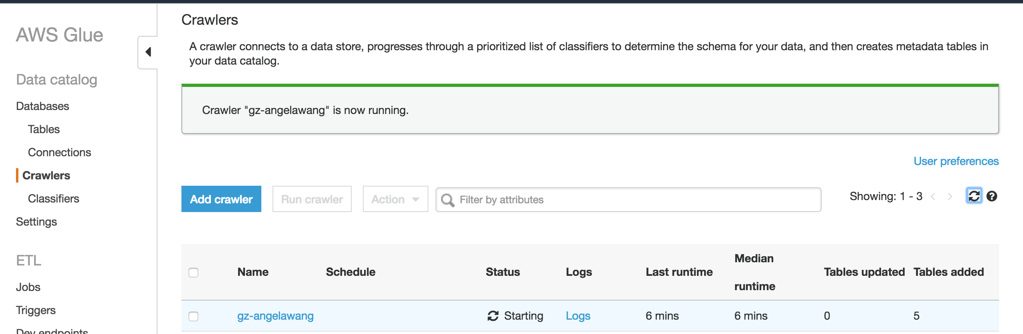

For failure, you can check the “Logs” hyperlink which will take you to the CloudWatch logs.

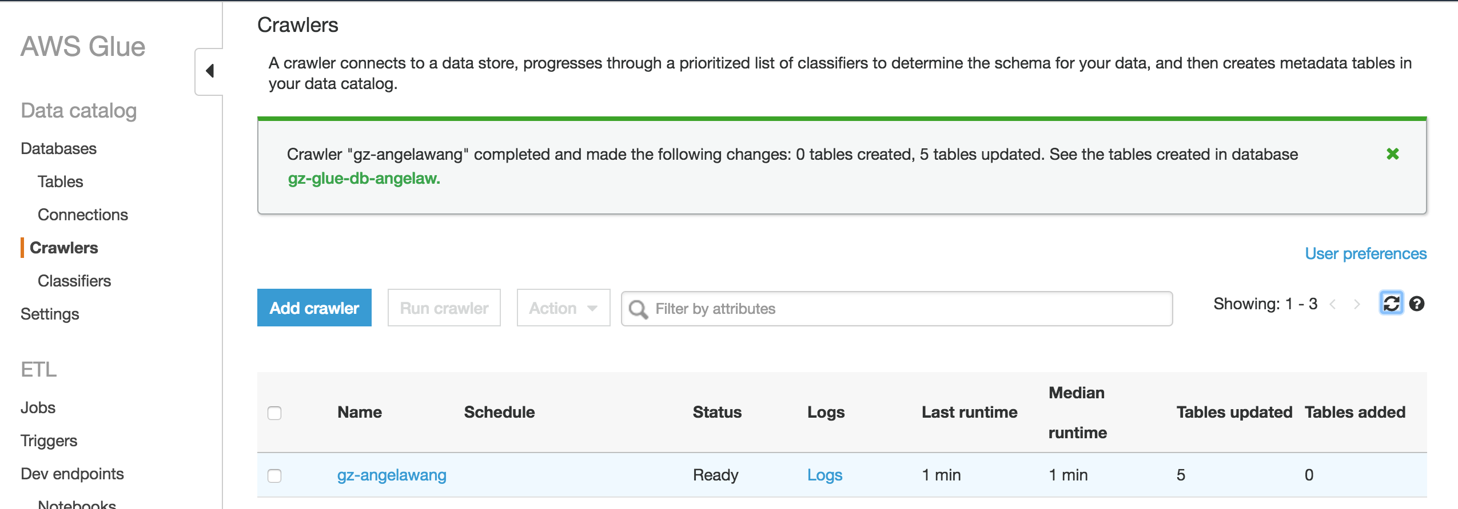

Now, let’s go to the Glue catalog DB to make sure that the table exists.

Click on “Databases” -> Select “gz-glue-db-<initials-suffix>” -> Click on “Tables in gz-glue-db-<initials-suffix>” or click on the hyperlink of the DB name, you will see the “customer” table as shown below

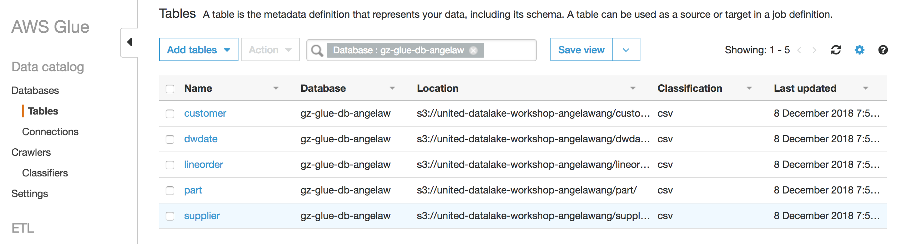

Click on the “customer” hyperlink to get to the external table details below

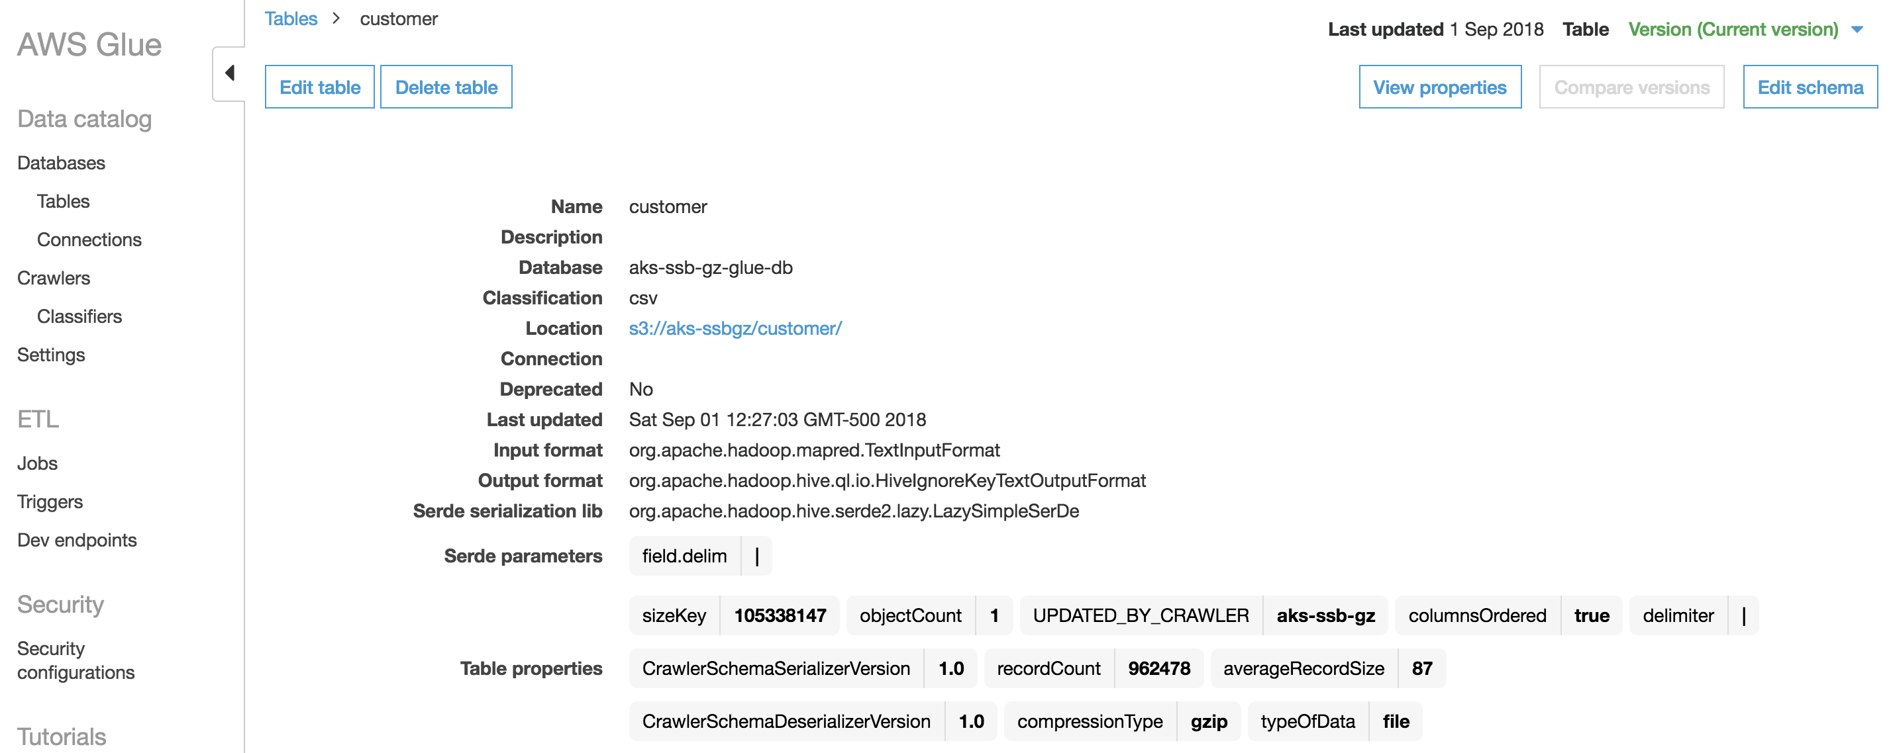

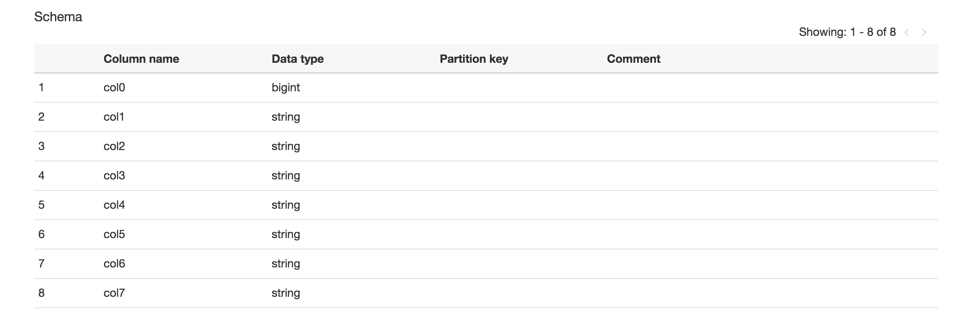

## Edit Table Schema

Since none of the data files has a header record, Glue crawler has assigned a default column naming convention as shown below (col0 to col7 for the customer table).

**CUSTOMER**

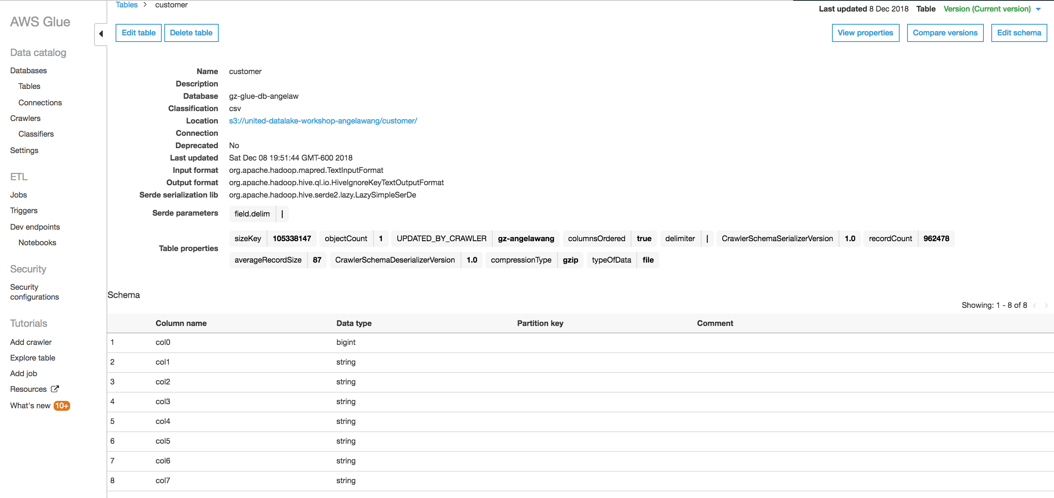

Click on “Edit Schema” and assign appropriate column names as per the mapping below.

c0 => c_custkey

c1 => c_name

c2 => c_address

c3 => c_city

c4 => c_nation

c5 => c_region

c6 => c_phone

c7 => c_mktsegment

**Note:** you may find it easier to do this part by sizing your browser and instructions window so they are side by side. 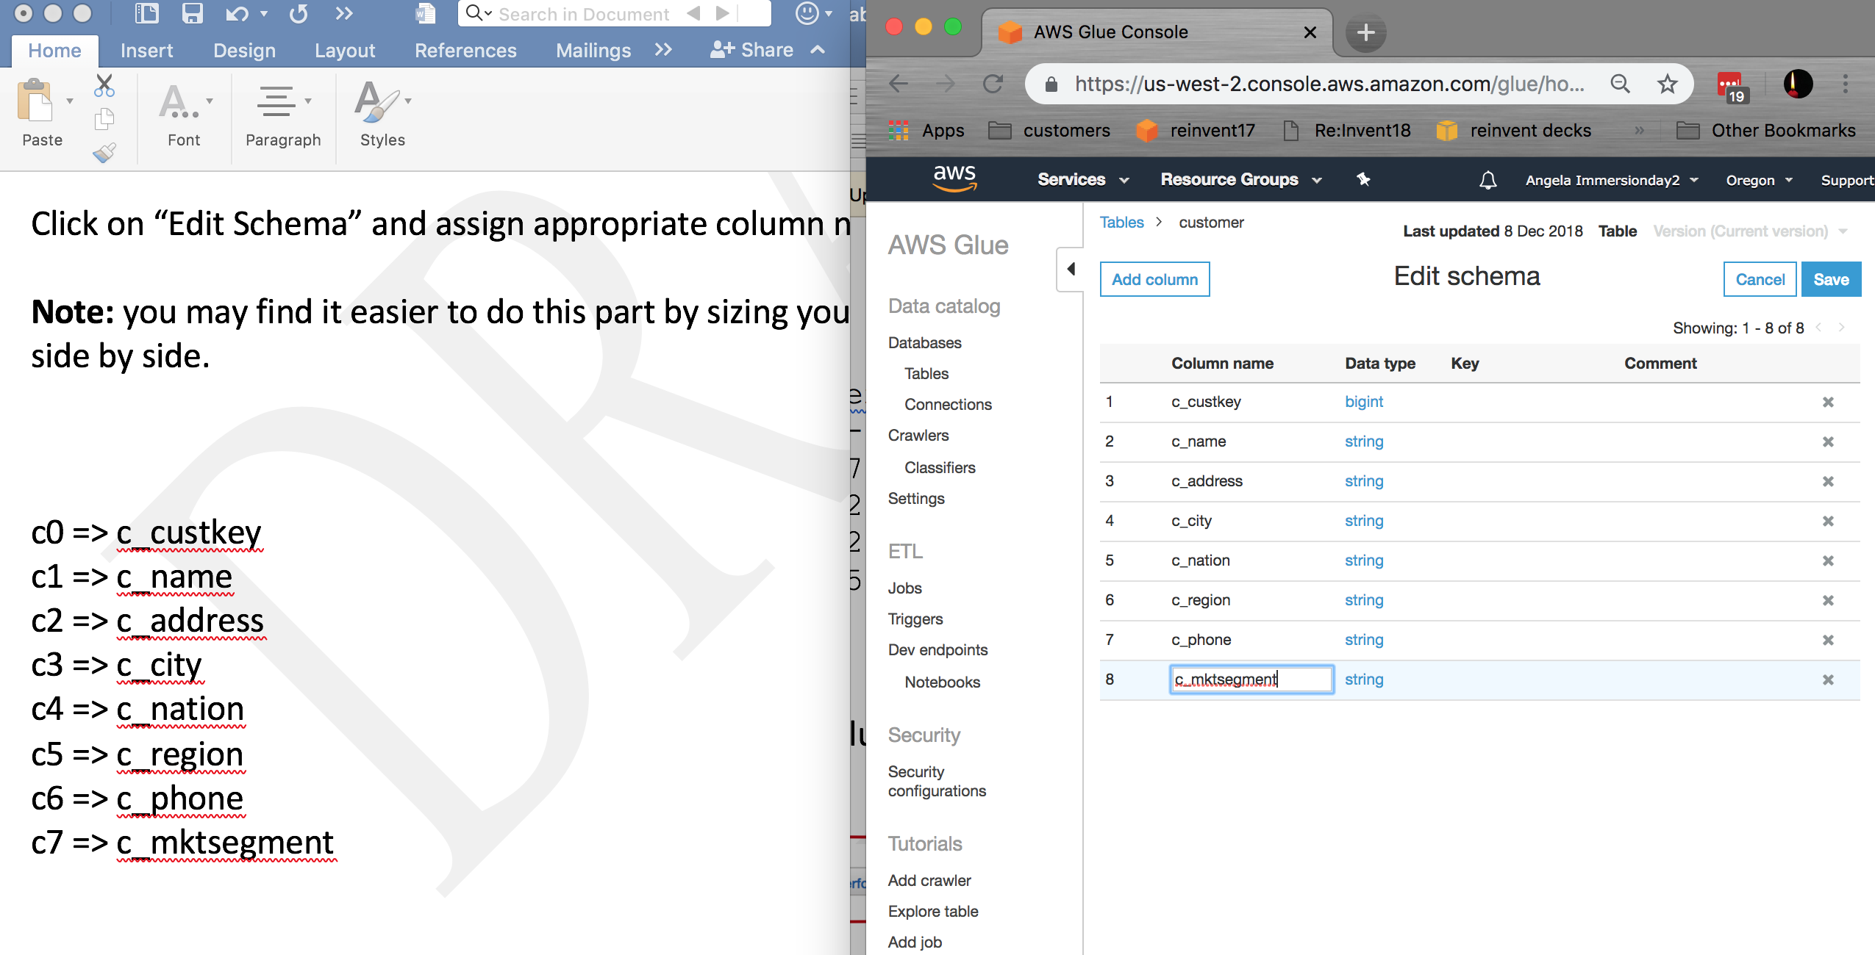

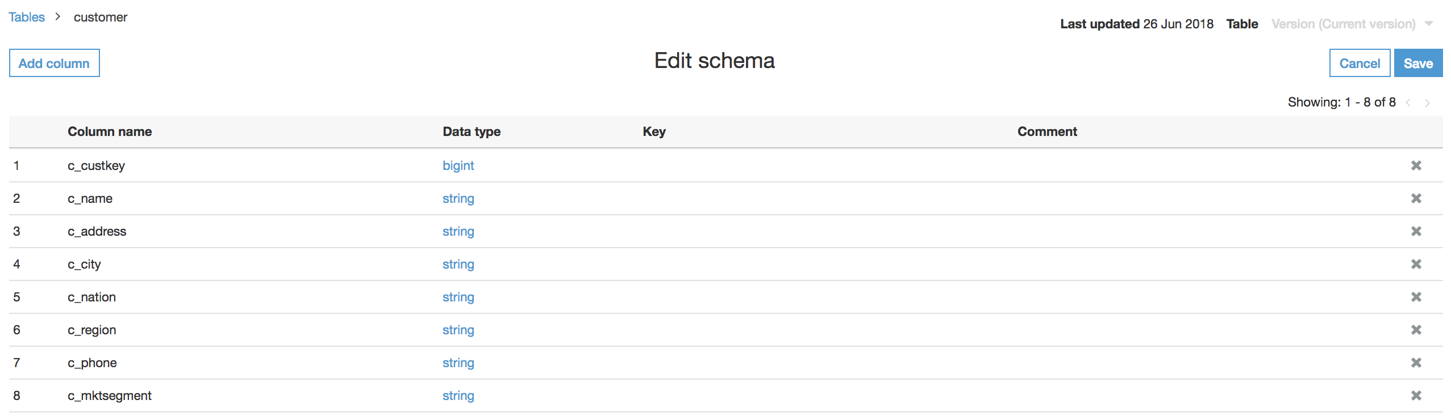

Click on “Save” once done.

Following the same process, update the table schema for the remaining tables

**DWDATE**

c0 => d_datekey

c1 => d_date

c2 => d_dayofweek

c3 => d_month

c4 => d_year

c5 => d_yearmonthnum

c6 => d_yearmonth

c7 => d_daynuminweek

c8 => d_daynuminmonth

c9 => d_daynuminyear

c10 => d_monthnuminyear

c11 => d_weeknuminyear

c12 => d_sellingseason

c13 => d_lastdayinweekfl

c14 => d_lastdayinmonthfl

c15 => d_holidayfl

c16 => d_weekdayfl

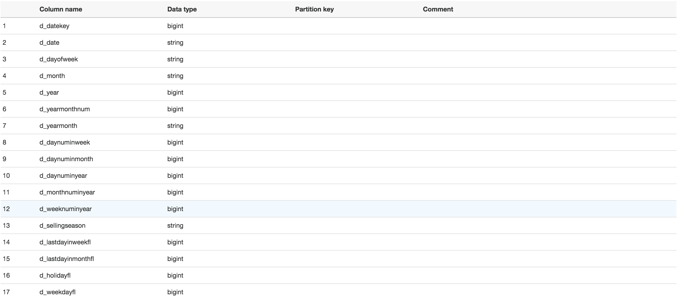

**PART**

c0 => p_partkey

c1 => p_name

c2 => p_mfgr

c3 => p_category

c4 => p_brand1

c5 => p_color

c6 => p_type

c7 => p_size

c8 => p_container

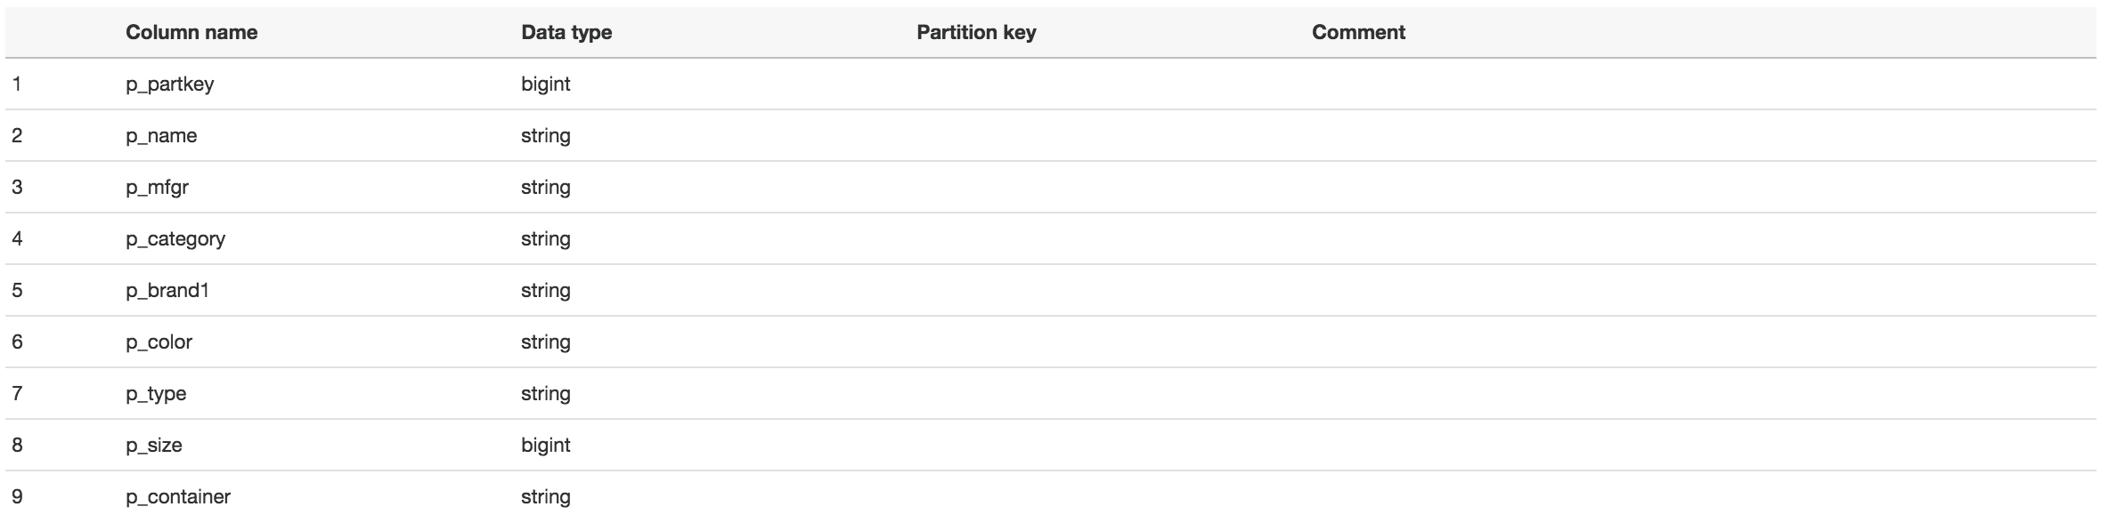

**SUPPLIER**

c0 => s_suppkey

c1 => s_name

c2 => s_address

c3 => s_city

c4 => s_nation

c5 => s_region

c6 => s_phone

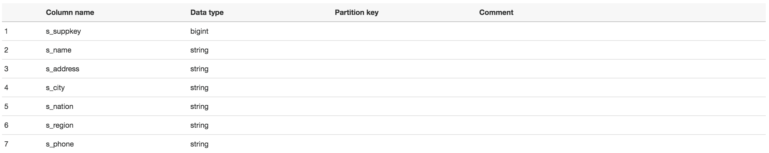

**LINEORDER**

c0 => lo_orderkey

c1 => lo_linenumber

c2 => lo_custkey

c3 => lo_partkey

c4 => lo_suppkey

c5 => lo_orderdate

c6 => lo_orderpriority

c7 => lo_shippriority

c8 => lo_quantity

c9 => lo_extendedprice

c10 => lo_ordertotalprice

c11 => lo_discount

c12 => lo_revenue

c13 => lo_supplycost

c14 => lo_tax

c15 => lo_commitdate

c16 => lo_shipmode

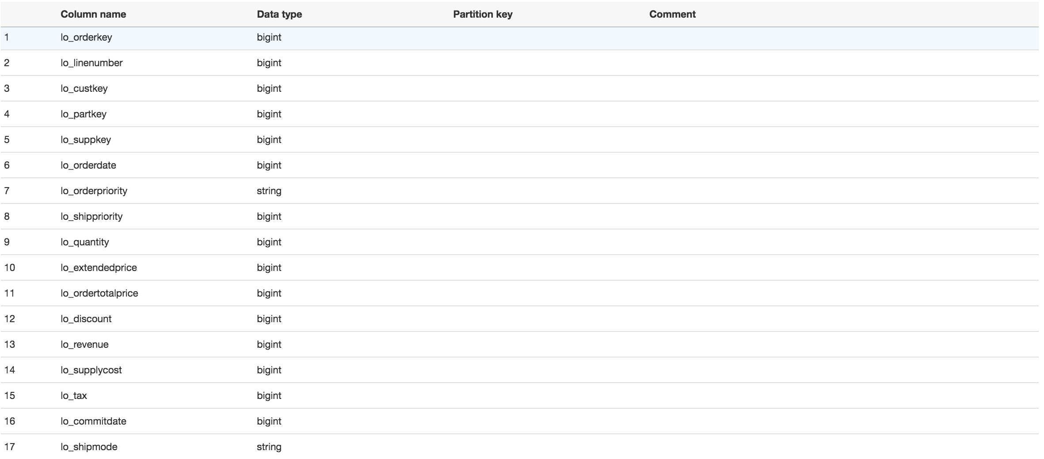

# Amazon Athena

[Amazon Athena](https://aws.amazon.com/athena) is an interactive query service that makes it easy to analyze data directly from Amazon S3 using standard SQL. Athena is serverless, so there is no infrastructure to set up or manage and you can start analyzing your data immediately. You don’t even need to load your data into Athena or have complex ETL processes. Athena works directly with data stored in S3.

Athena uses [Apache Presto](https://prestodb.io/), a distributed SQL engine to run queries. It also uses [Apache Hive](https://cwiki.apache.org/confluence/display/Hive/GettingStarted#GettingStarted-DDLOperations) to create, drop, and alter tables and partitions. You can write Hive-compliant DDL statements and ANSI SQL statements in the Athena query editor. You can also use complex joins, window functions and complex datatypes on Athena. Athena uses an approach known as schema-on-read, which allows you to project your schema on to your data at the time you execute a query. This eliminates the need for any data loading or ETL.

Athena charges you by the amount of data scanned per query. You can save on costs and get better performance if you partition the data, compress data, or convert it to columnar formats such as Apache Parquet. For more information, see [Athena pricing](http://aws.amazon.com/athena/pricing).

***Note***

*To use AWS Glue with Amazon Athena, you must upgrade your Athena data catalog to the AWS Glue Data Catalog. For more information about upgrading your Athena data catalog, see step-by-step guide* [*here*](http://docs.aws.amazon.com/athena/latest/ug/glue-upgrade.html)*.*

## Query using Athena

Now that we got the create external tables setup in the Glue catalog, let’s go to Athena console and run the few queries referencing the same external tables created above to analyze the data.

***Note***

*You can also navigate to the Amazon Athena console from Glue console by choosing “View data”*

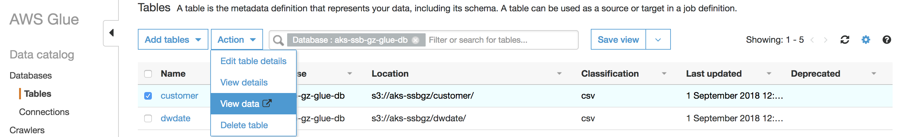

Ensure the correct database is selected in the Athena console. If the tutorial option pops up, just skip the toturial.

-- Query 1

-- Restrictions on only one dimension.

select

sum(lo_extendedprice*lo_discount) as revenue

from

lineorder,

dwdate

where lo_orderdate = d_datekey

and d_year = 1997

and lo_discount between 1 and 3

and lo_quantity < 24;

**Run time: 2 minutes 13 seconds, Data scanned: 25.12GB**

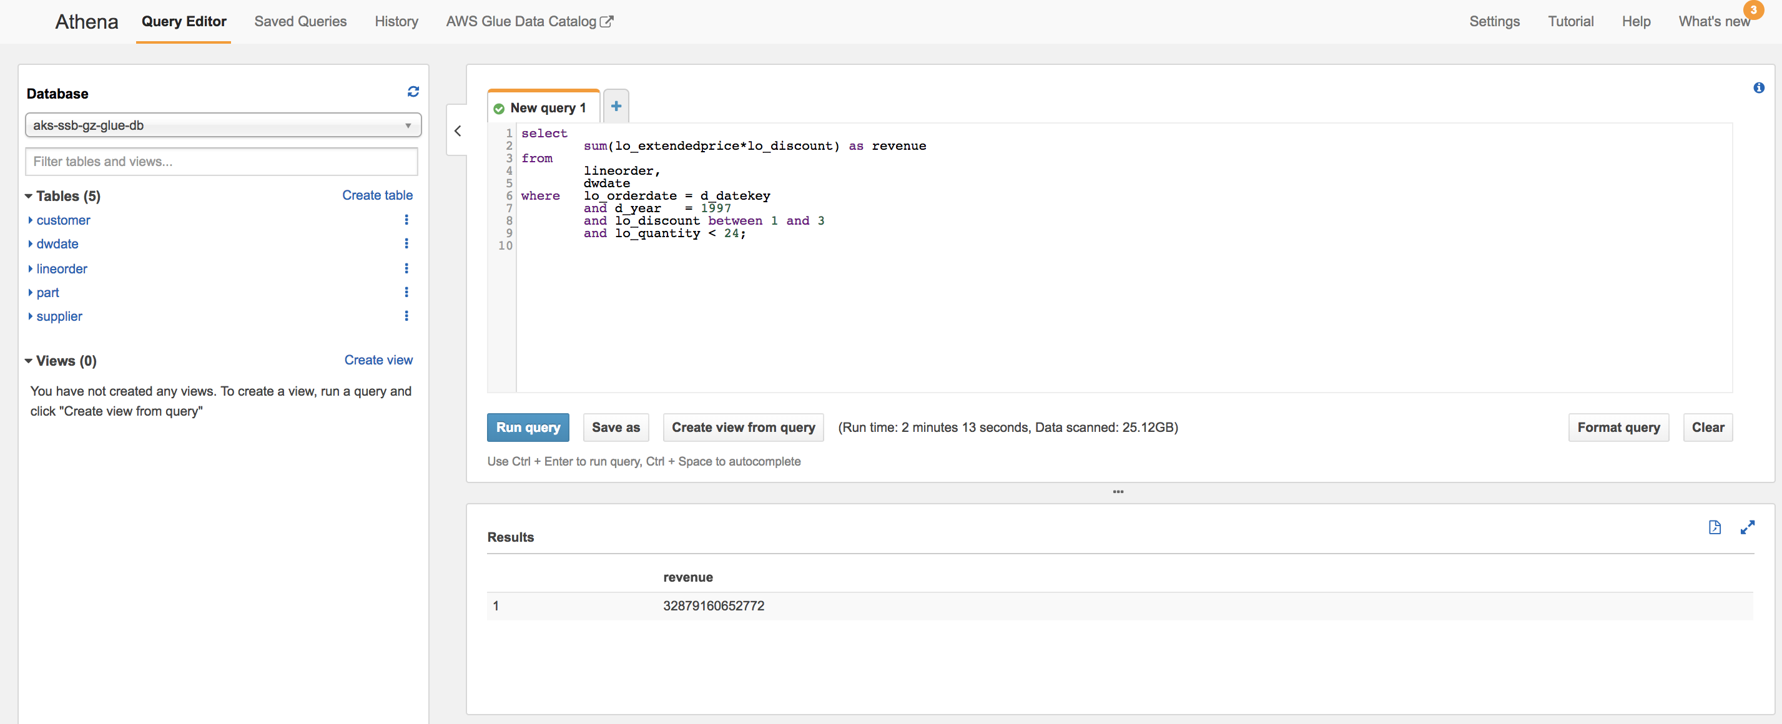

***Note***

*While a query is running in Athena, you can run another query by clicking on the* ***New Query*** *button. The current query will continue to run in the background. You can check the status of all queries in the History Tab. You can also kick off all the three queries above in parallel from three different query tabs.*

-- Query 2

-- Restrictions on two dimensions

select

sum(lo_revenue),

d_year ,

p_brand1

from

lineorder,

dwdate ,

part ,

supplier

where lo_orderdate = d_datekey

and lo_partkey = p_partkey

and lo_suppkey = s_suppkey

and p_category = 'MFGR#12'

and s_region = 'AMERICA'

group by

d_year,

p_brand1

order by

d_year,

p_brand1;

**Run time: 2 minutes 51 seconds, Data scanned: 25.18GB**

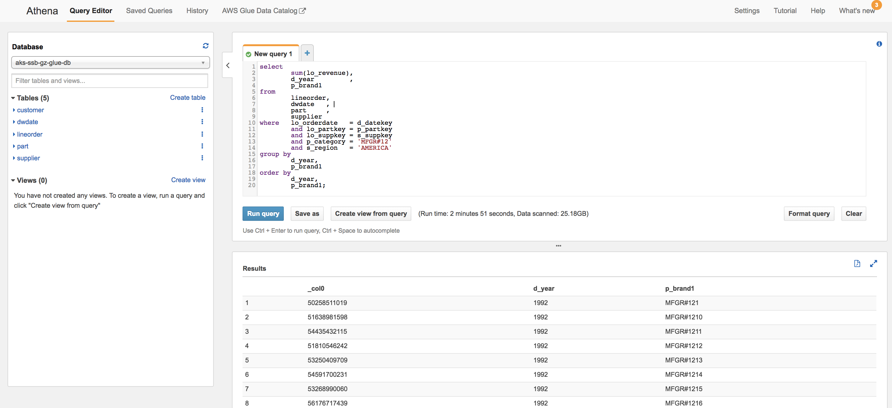

-- Query 3

-- Drill down in time to just one month

select

c_city,

s_city,

d_year,

sum(lo_revenue) as revenue

from

customer ,

lineorder,

supplier ,

dwdate

where lo_custkey = c_custkey

and lo_suppkey = s_suppkey

and lo_orderdate = d_datekey

and

(c_city ='UNITED KI1'

or c_city='UNITED KI5')

and

(s_city ='UNITED KI1'

or s_city='UNITED KI5')

and d_yearmonth = 'Dec1997'

group by

c_city,

s_city,

d_year

order by

d_year asc,

revenue desc;

**Run time: 2 minutes 54 seconds, Data scanned: 25.25GB**

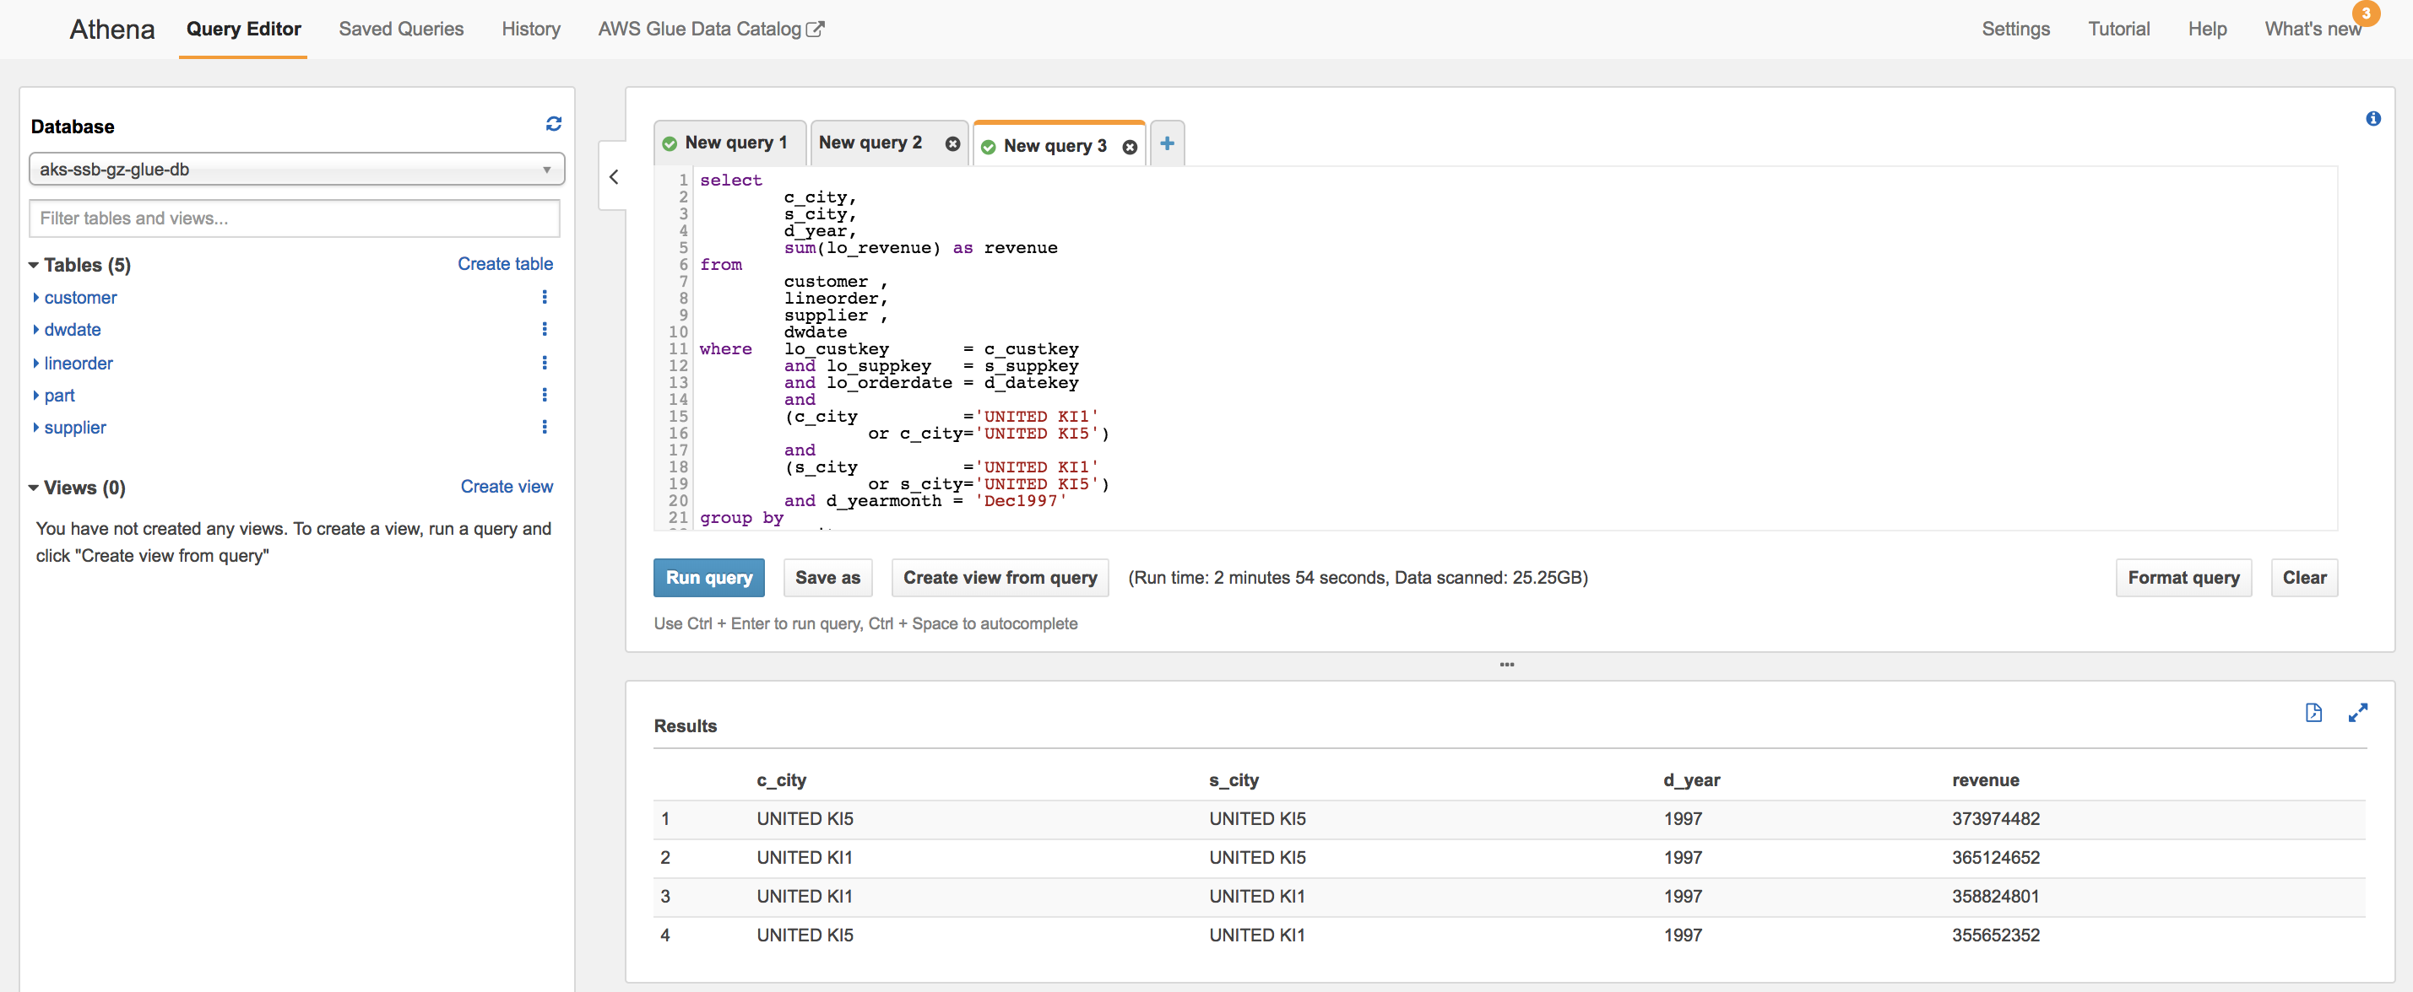

# Glue ETL - Transform Data - CSV to Parquet

It is a best practice for performance reasons to store the data in parquet file format and snappy compression for both Athena and Redshift Spectrum. In this tutorial, I will show two options for this transformation needs using Glue ETL.

## Using Glue ETL Autogenerated Spark Code

So, let’s use a Glue ETL job to convert the data from “CSV, gzip” to “parquet, snappy”.

Navigate to “ETL -> Jobs” and click on “Add job” to get to the “Job properties” screen below

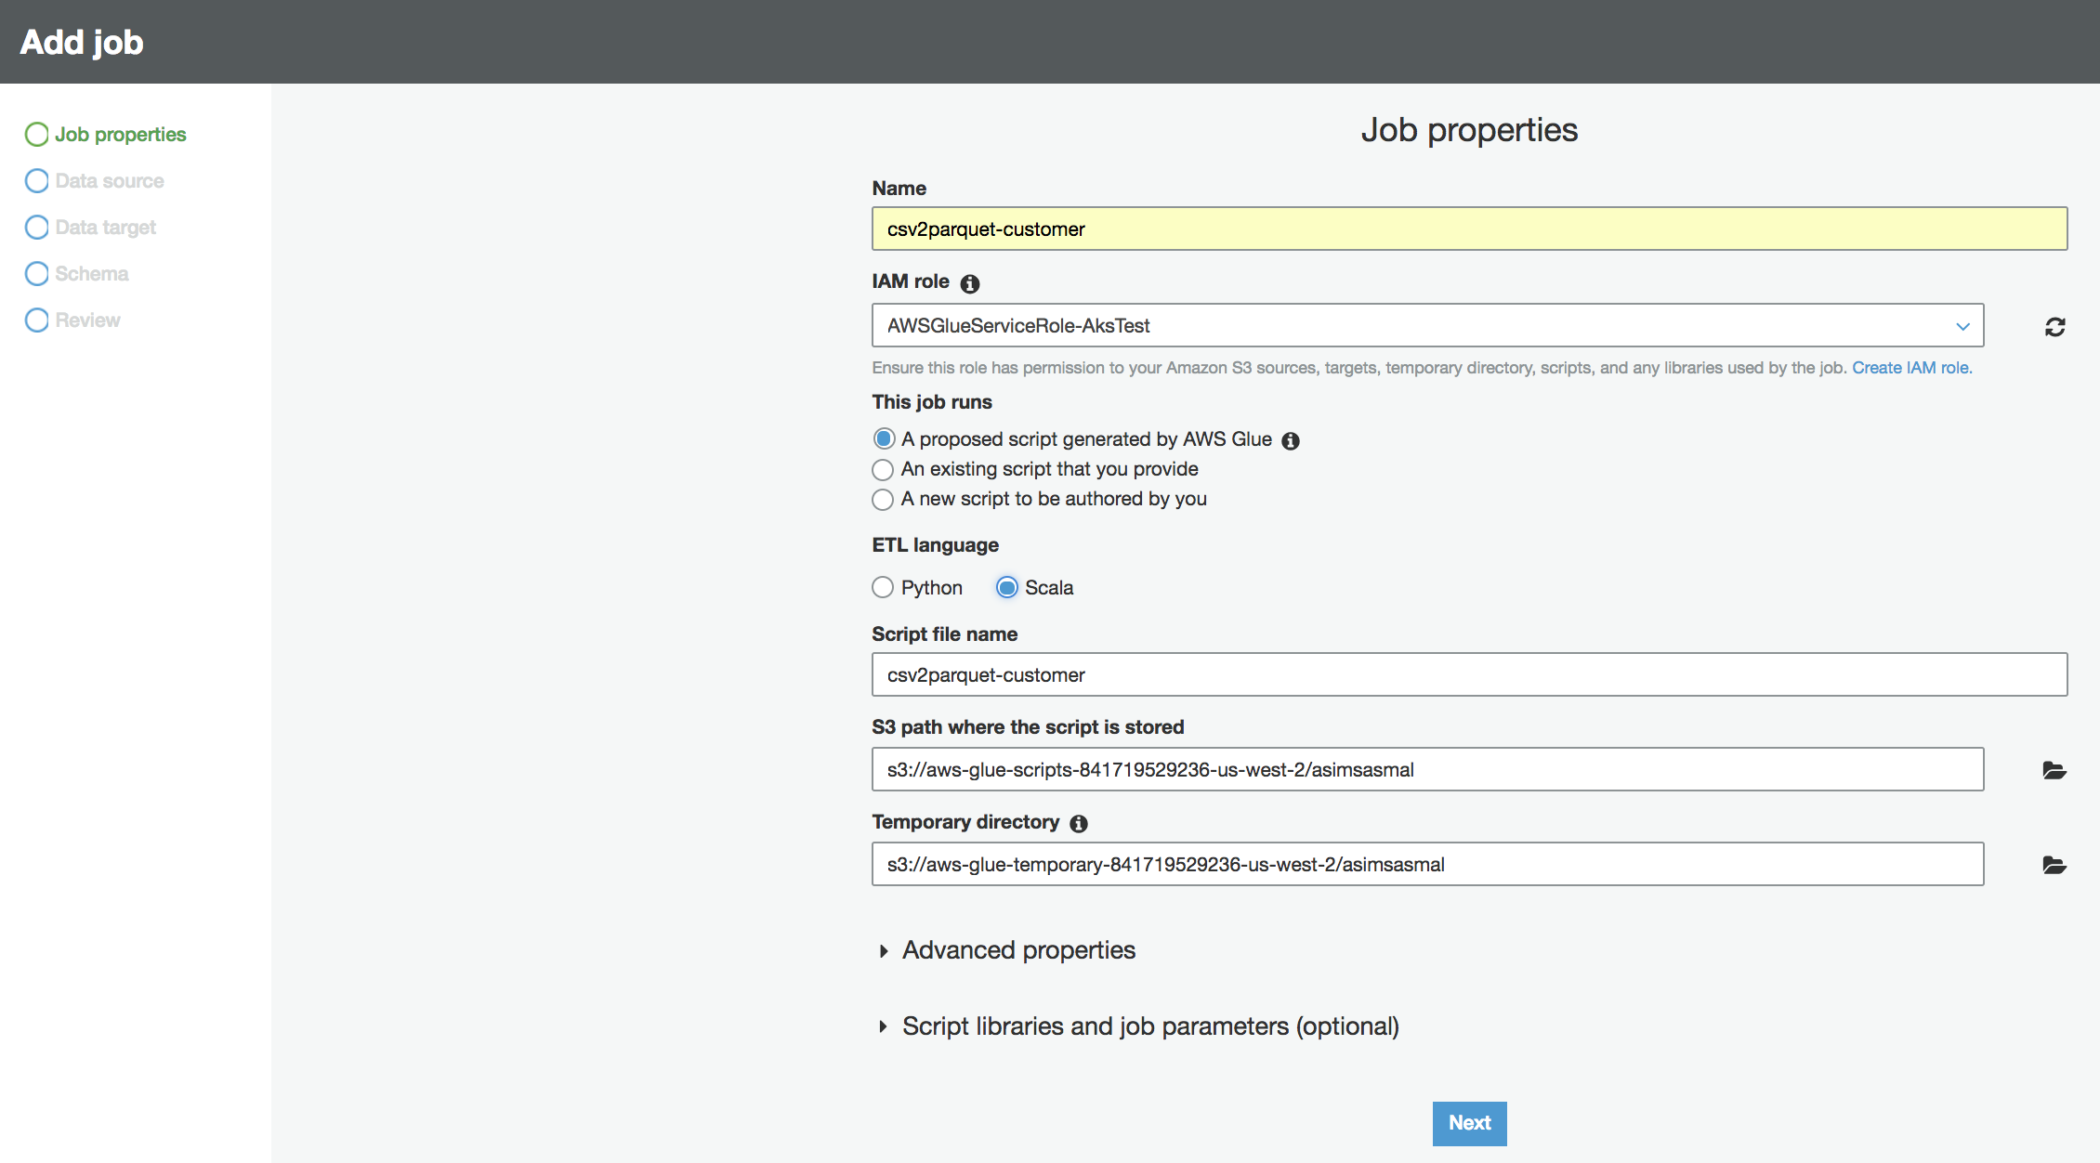

Name the Job as “csv2parquet-customer-<initials-suffix>”. For this lab, choose the following IAM role:

* AWSGlueServiceRole-angelawang

Under “This job runs” option, out of the three options provided by Glue ETL, I am choosing “A proposed script generated by AWS Glue” and “Scala” as the “ETL language”.

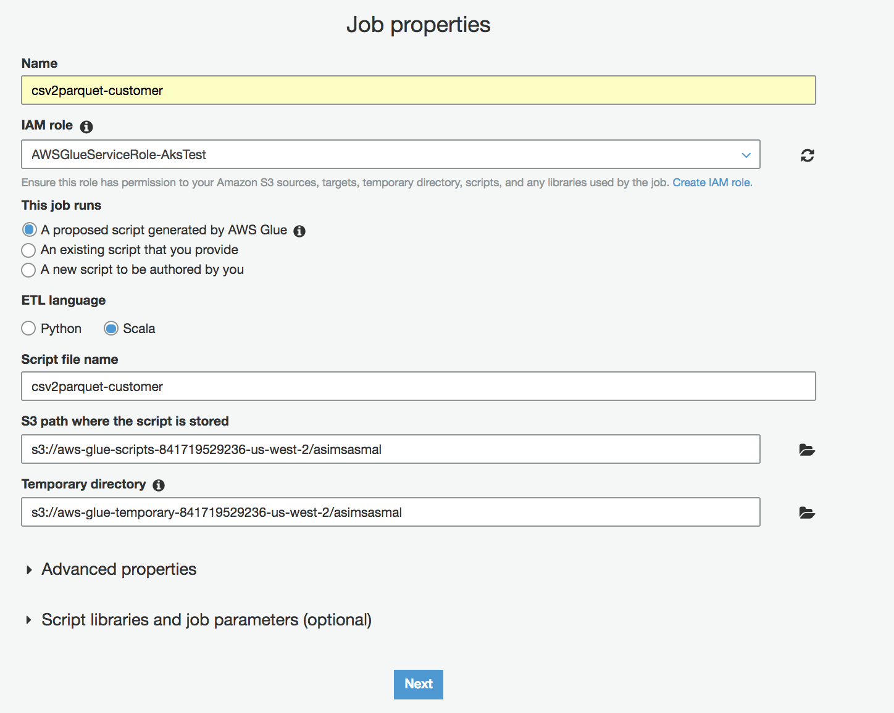

Click on “Next” to get to the “Choose your data sources” screen as below where I have filtered by “gz-glue-db-<initials-suffix>”.

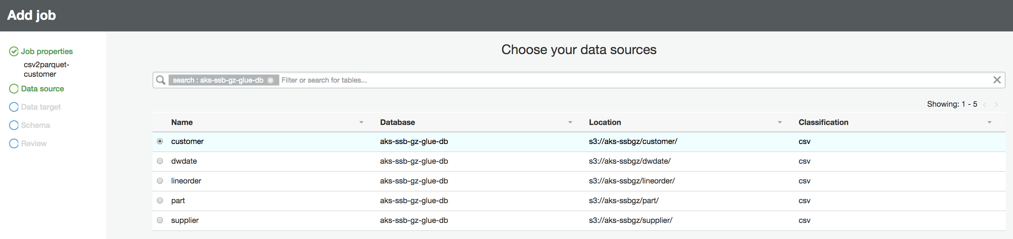

* Select “customer” table and click “Next” to go to “Choose your data targets” screen as shown below where I have selected “Create tables in your data target” option with target as S3 in an existing bucket and folder for customer table – “S3://united-datalake-workshop-<initials-suffix>/parquet/customer”.

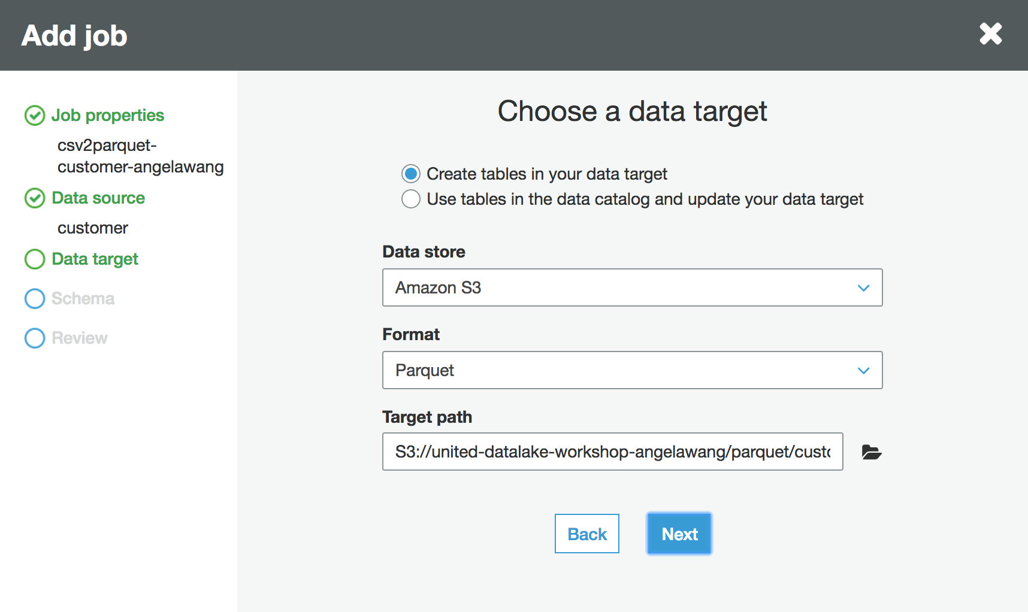

Click “Next” to get to the “Map the source columns to target columns.” screen to define the right column names and data types. Leave everything else default except the data type for “c_custkey” on Target to be “bigint” as below.

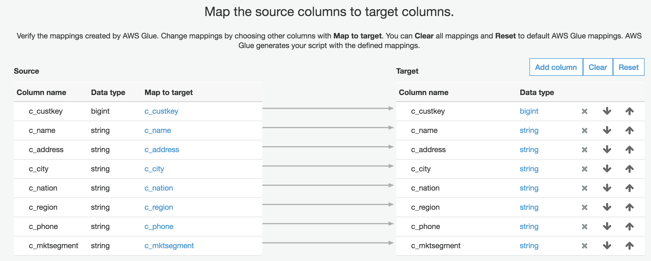

Click “Next” to get to the review screen.

Once you have reviewed, click on “Save job and edit script” button which will take you to the screen below with the autogenerated Spark Scala code by Glue. You can modify the script on this screen if needed and hit the “Save” button.

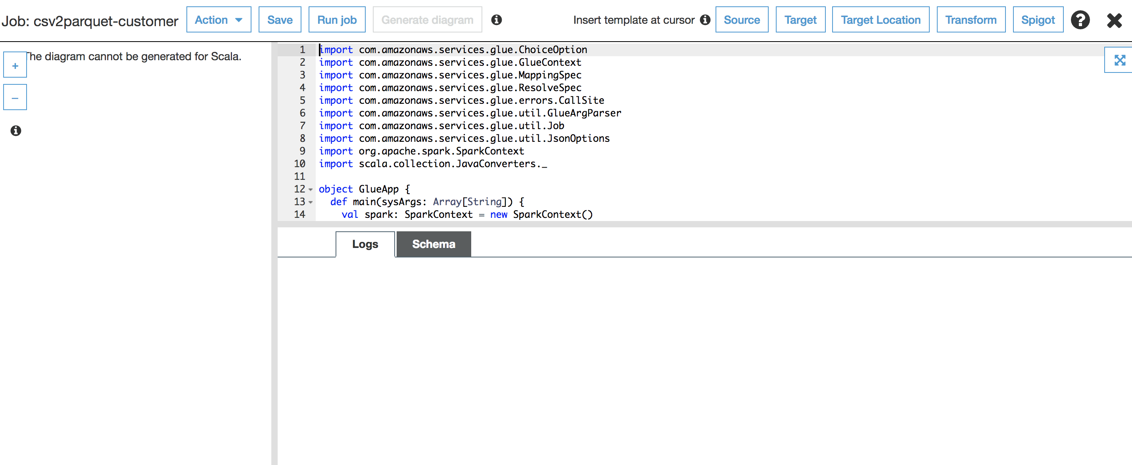

Click on “Run job” button as shown above and then again click on “Run job” button on the popup window since there is nothing to change. Wait for the Glue ETL job to complete. You will notice the logs rolling as the job progresses in the screen shot below.

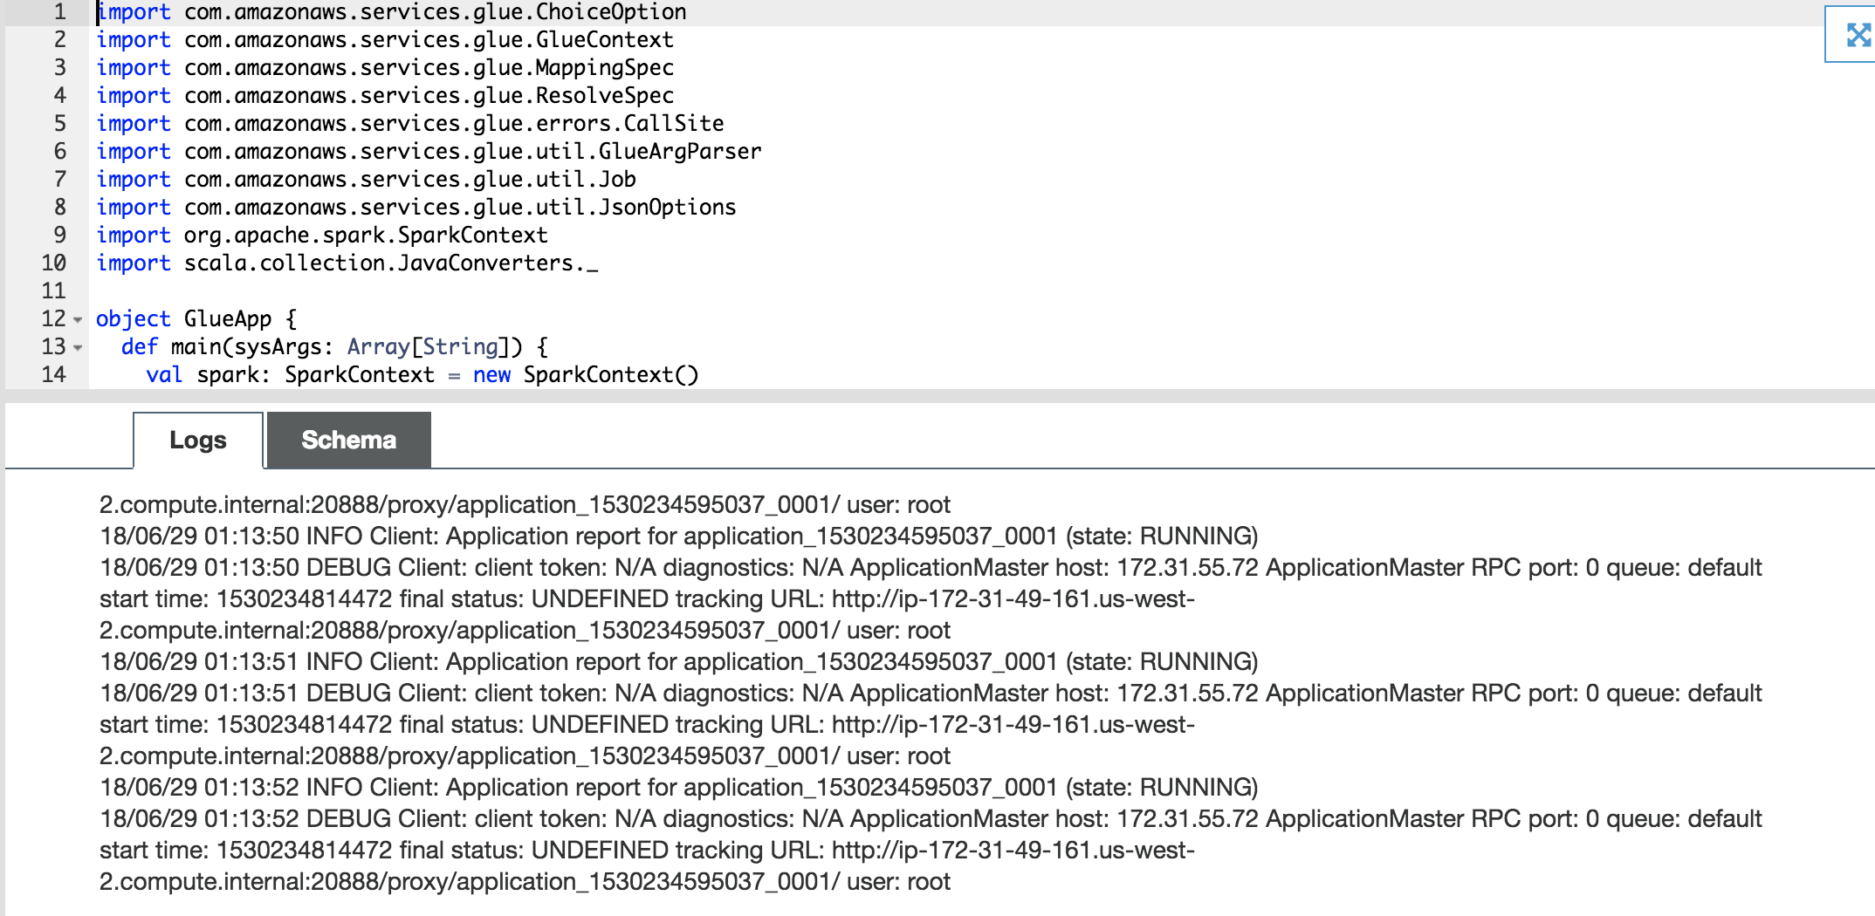

You can also go to Cloud Watch for the same logs by clicking on “Logs” hyperlink right beside “Succeeded” status. You don’t have to wait for the job to reach to success status to check the logs.

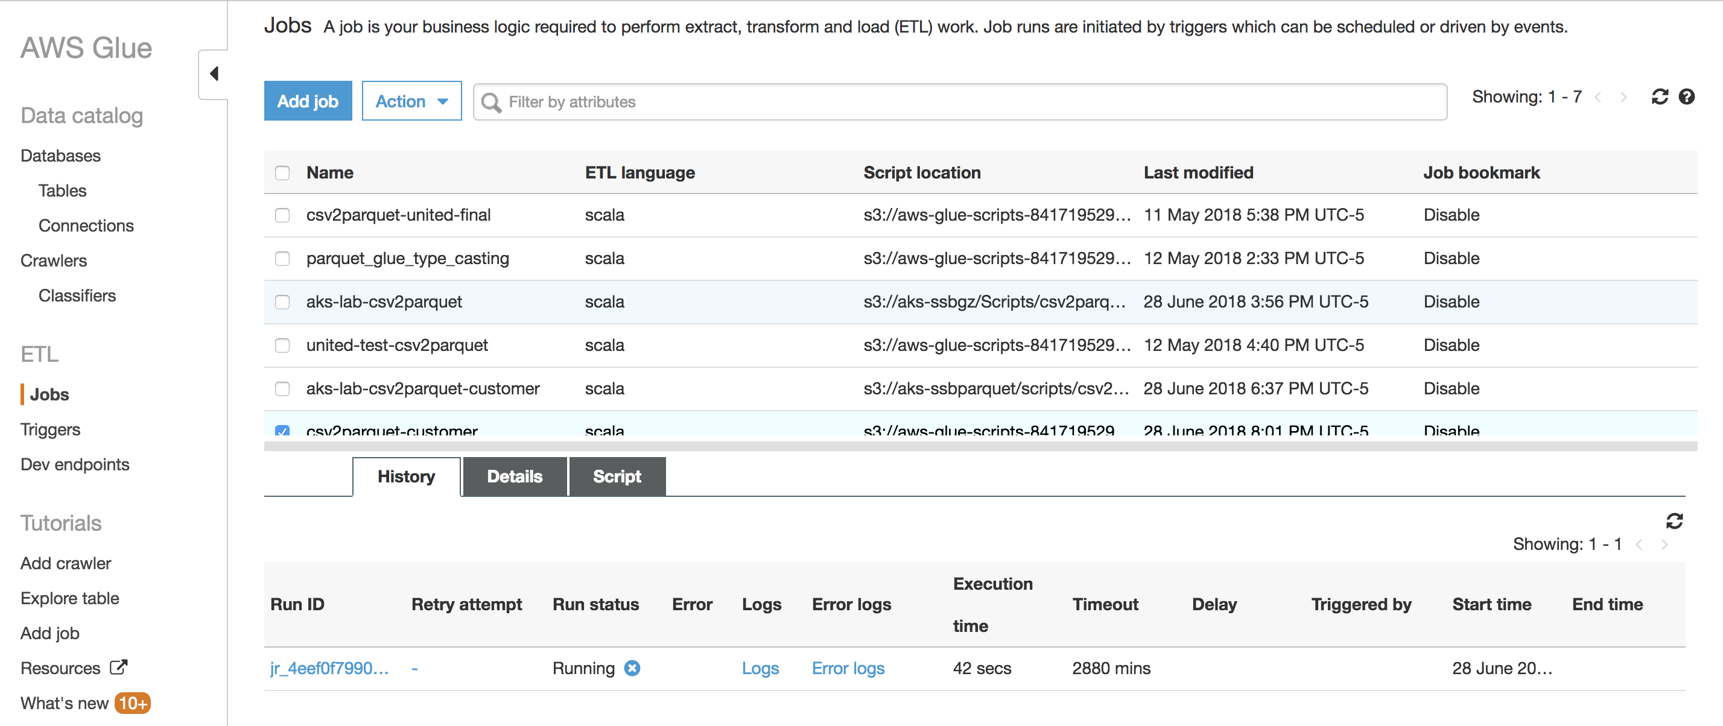

***Note***

*Just a call out that unlike Spark on an EMR cluster, you don’t have an option in Glue to check the Spark job DAG or other native details as you would do let’s say in an EMR cluster outside of what is available from Glue job metrics standpoint which can be good enough for the job.*

Following the same process, create Glue ETL jobs for remaining four tables.

**Job 2:**

* Job name: csv2parquet-dwdate-<initial-suffix>
* Source table: dwdate
* Data target path: s3://united-datalake-workshop-<initial-suffix>/parquet/dwdate

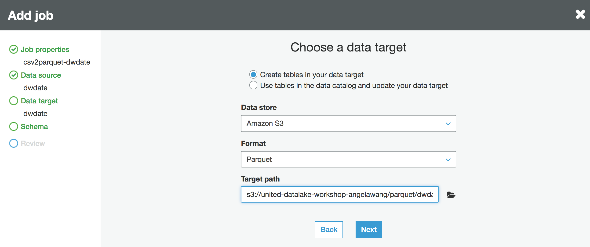

* Note: you don’t have to update any of the data types in the target datasource mapping

**Job 3:**

* Job name: csv2parquet-part-<initial-suffix>
* Source table: part
* Data target path: s3://united-datalake-workshop-<initial-suffix>/parquet/part
* Note: you don’t have to update any of the data types in the target datasource mapping

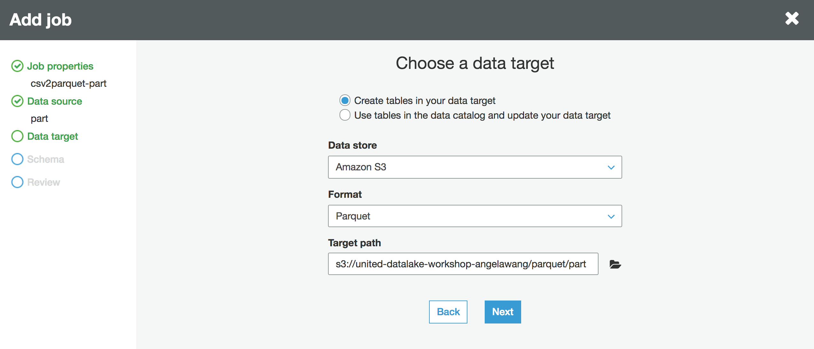

**Job 3:**

* Job name: csv2parquet- supplier-<initial-suffix>
* Source table: supplier
* Data target path: s3://united-datalake-workshop-<initial-suffix>/parquet/supplier
* Note: you don’t have to update any of the data types in the target datasource mapping

## Using Glue ETL Custom Spark Code

For the LINEORDER table, I am going to have my own simple Scala script to do the conversion.

To create the Glue ETL Job – “csv2parquet-lineorder-custom-scala-code-<initials-suffix>” follow the steps below.

Navigate to “ETL -> Jobs” and click on “Add job” to get to the “Job properties” screen below

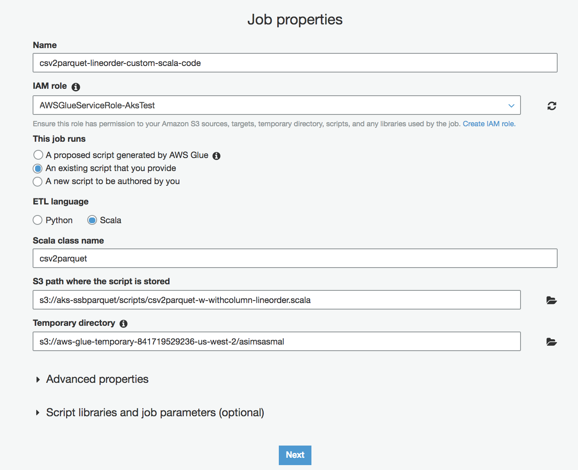

Under “**This job runs**” section, out of the three options provided, I am choosing “An existing script that you provide” since I have my own code.

Choose “Scala” as the “ETL language”.

Here is the S3 path where the code is:

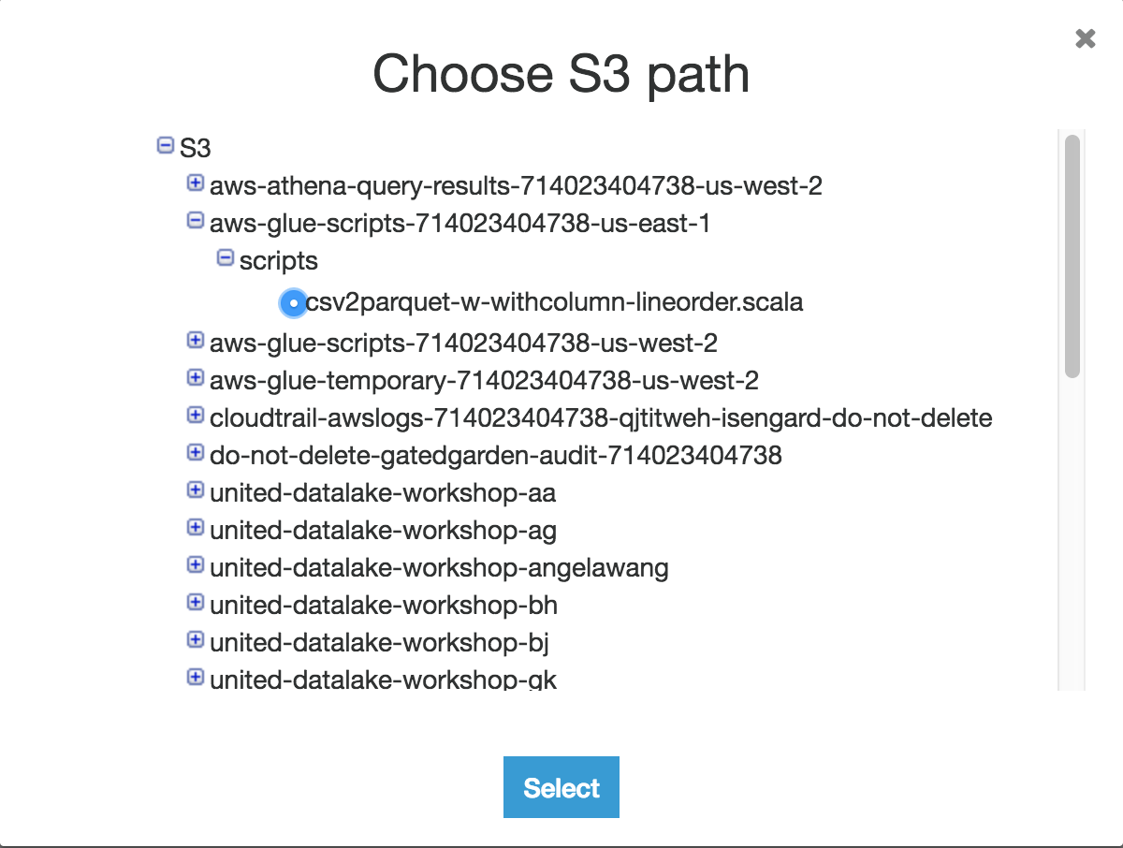

“S3://aws-glue-scripts-<acccountID>-us-east-1/scripts/csv2parquet-w-withcolumn-lineorder.scala”

Here is the code for review:

//Two job parameters are required for this script

//1 - S3 path for CSV input files to be converted to parquet

//2 - S3 path for parquet output files to be written

import com.amazonaws.services.glue.GlueContext

import com.amazonaws.services.glue.util.GlueArgParser

import com.amazonaws.services.glue.util.Job

import org.apache.spark.SparkContext

import org.apache.spark.sql.{SparkSession}

import scala.collection.JavaConverters._

import org.apache.spark.sql.types._

object csv2parquet {

def main(sysArgs: Array[String]) {

val session = SparkSession.builder.getOrCreate()

val args = GlueArgParser.getResolvedOptions(sysArgs,Seq("JOB_NAME","s3ippath","s3oppath").toArray)

val s3ippathval = args("s3ippath")

val s3oppathval = args("s3oppath")

val csvfile = session.read.format("csv").option("delimiter","|").option("header", "false").load(s3ippathval)

val csvfile1 = csvfile

.withColumn("lo_orderkey", csvfile.col("_c0").cast(LongType)).drop("_c0")

.withColumn("lo_linenumber", csvfile.col("_c1").cast(LongType)).drop("_c1")

.withColumn("lo_custkey", csvfile.col("_c2").cast(LongType)).drop("_c2")

.withColumn("lo_partkey", csvfile.col("_c3").cast(LongType)).drop("_c3")

.withColumn("lo_suppkey", csvfile.col("_c4").cast(LongType)).drop("_c4")

.withColumn("lo_orderdate", csvfile.col("_c5").cast(LongType)).drop("_c5")

.withColumn("lo_orderpriority", csvfile.col("_c6")).drop("_c6")

.withColumn("lo_shippriority", csvfile.col("_c7").cast(LongType)).drop("_c7")

.withColumn("lo_quantity", csvfile.col("_c8").cast(LongType)).drop("_c8")

.withColumn("lo_extendedprice", csvfile.col("_c9").cast(LongType)).drop("_c9")

.withColumn("lo_ordertotalprice", csvfile.col("_c10").cast(LongType)).drop("_c10")

.withColumn("lo_discount", csvfile.col("_c11").cast(LongType)).drop("_c11")

.withColumn("lo_revenue", csvfile.col("_c12").cast(LongType)).drop("_c12")

.withColumn("lo_supplycost", csvfile.col("_c13").cast(LongType)).drop("_c13")

.withColumn("lo_tax", csvfile.col("_c14").cast(LongType)).drop("_c14")

.withColumn("lo_commitdate", csvfile.col("_c15").cast(LongType)).drop("_c15")

.withColumn("lo_shipmode", csvfile.col("_c16")).drop("_c16")

csvfile1.printSchema()

csvfile1.write.mode("overwrite").parquet(s3oppathval)

Job.commit()

}

}

Now, let’s define the job parameters under “Script libraries and job parameters (optional)” section as below and enter the following two parameters

--s3ippath => s3://united-datalake-workshop-<initials-suffix>/lineorder/

--s3oppath => s3://united-datalake-workshop-<initials-suffix>/parquet/lineorder/

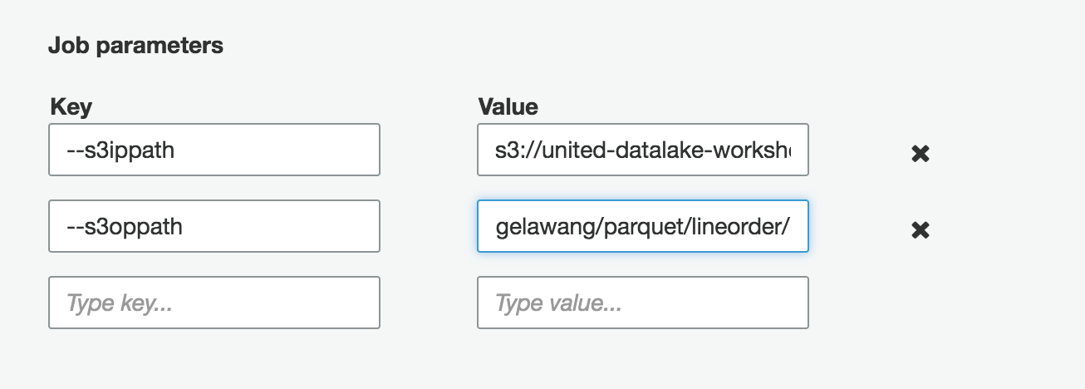

Click “Next” to get to the “Connections” screen, however, in the code, I am not going to read data from anywhere else, so you can click “Next” on that screen as well to get the “Review” screen.

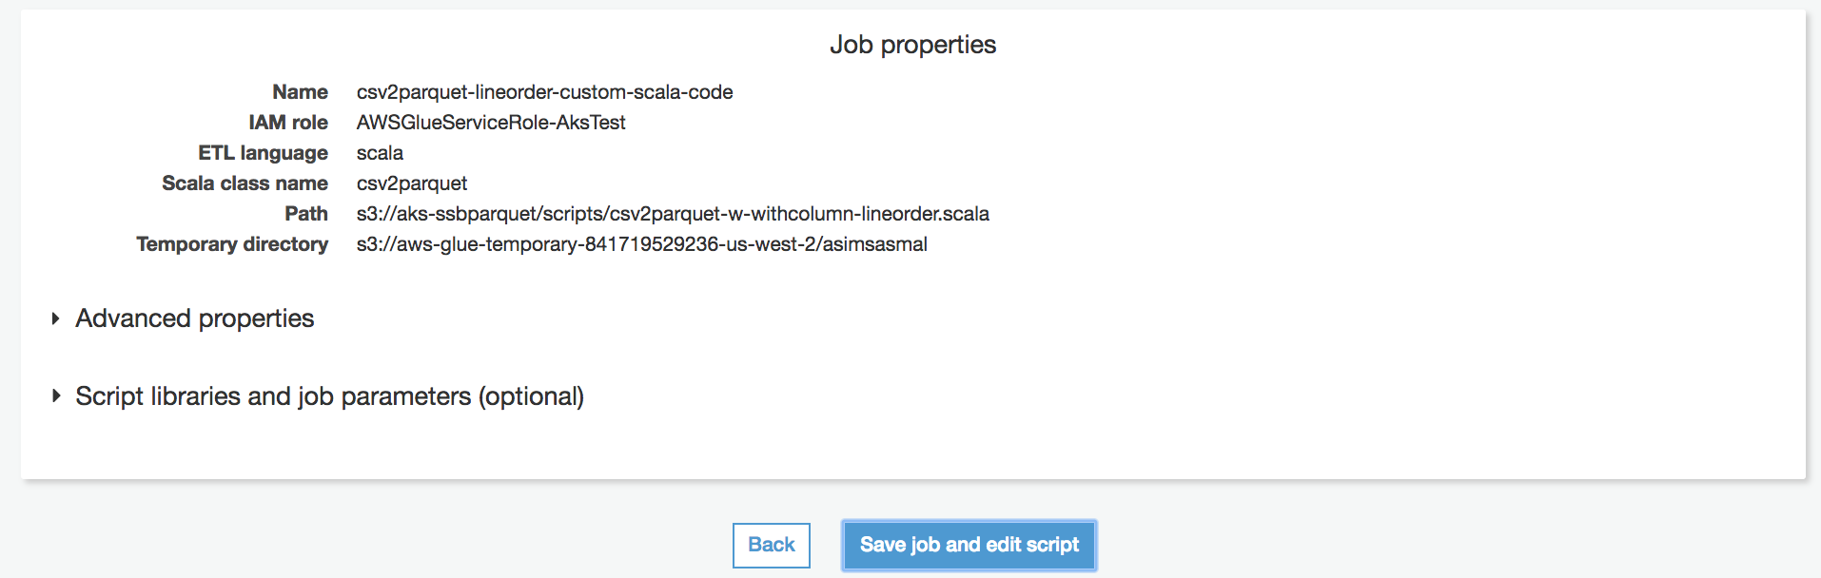

Click on “Save job and edit script” button to get to the below screen

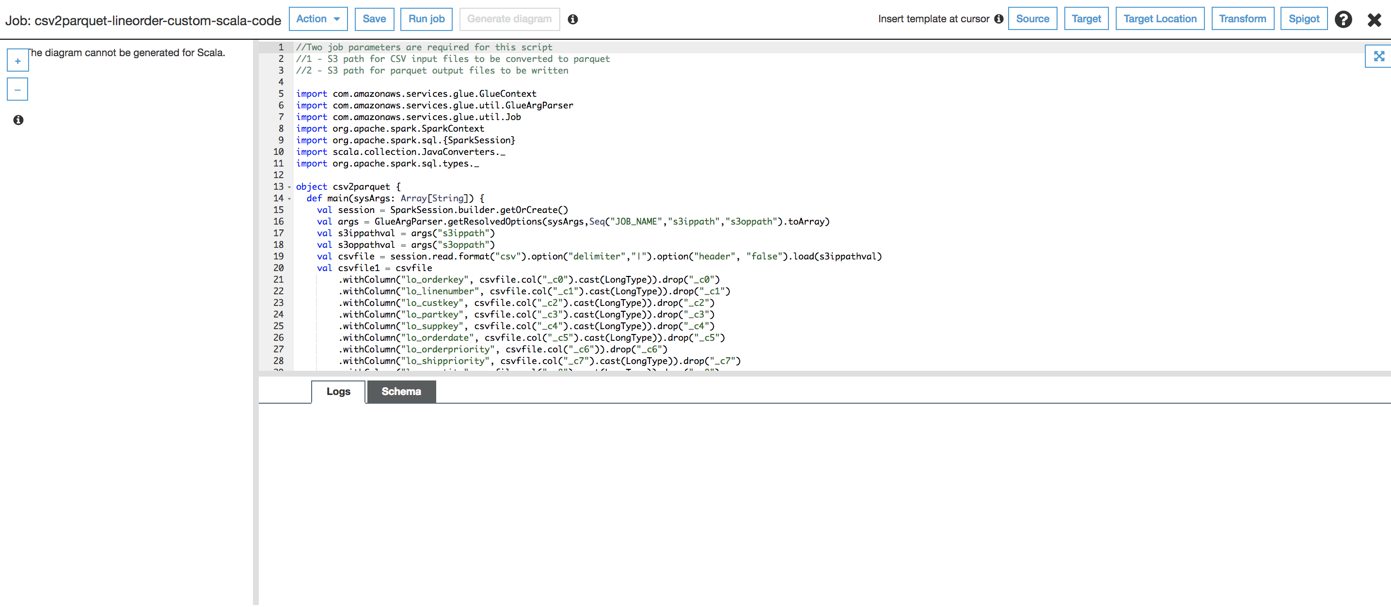

Now ready to run the job. Click on “Run job” and wait for the completion.

Let’s do a sanity check in S3 bucket – “S3://united-datalake-workshop-<initials-suffix>/parquet” to see the folders for each table

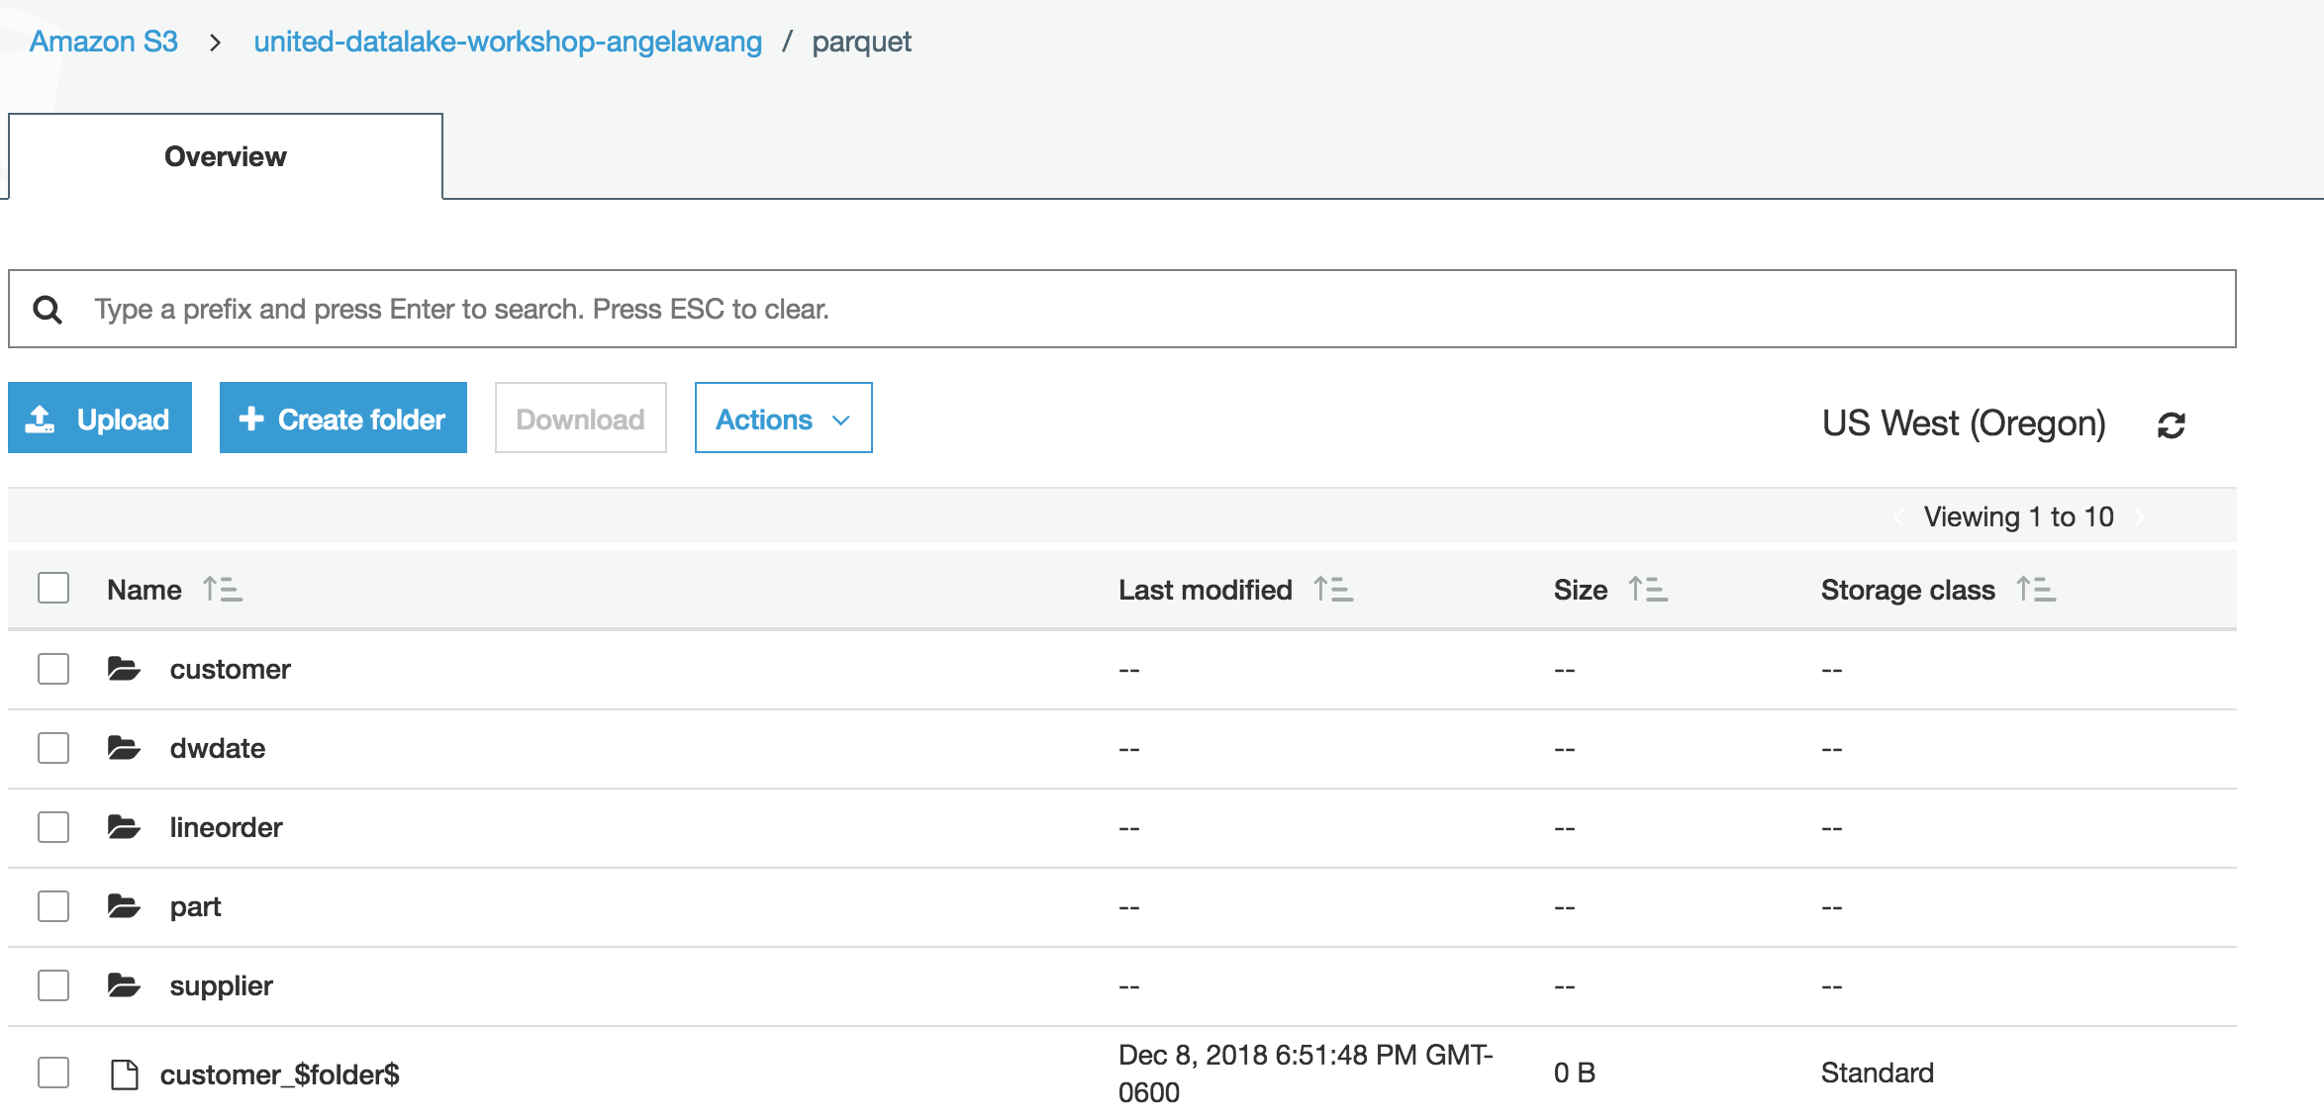

# Crawl and Create Parquet Tables

Now that we got the data converted to parquet file format and snappy compression, let’s create a new Glue catalog DB - “parquet-glue-db-<initials-suffix>” and also the external tables using newly created parquet data using Glue crawler as explained earlier in this document for CSV data.

***Note***

* *For this lab, instead of modifying the existing crawler job – “gz*-<initials-suffix>*” for “CSV and gzip” data, I would create a new crawler job – “parquet*-<initials-suffix>*”.*
* *No need to edit schema after the crawler jobs finish since we have already assigned appropriate schema in the Glue ETL job.*

Here are the new tables under Glue catalog DB – “parquet-glue-db-<initials-suffix>”.

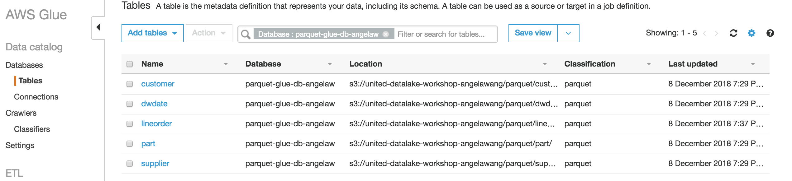

# Rerun Queries using Athena (using Parquet tables)

Now that we got the external tables setup for the parquet data, let’s rerun the same queries using Athena to prove out that parquet file format provides much better performance.

In Athena, ensure the new database we created for parquet files are selected:

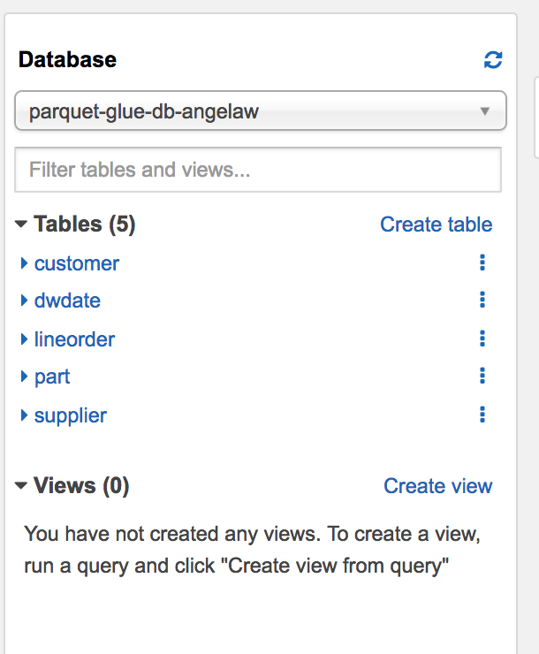

-- Query 1

-- Restrictions on only one dimension.

select

sum(lo_extendedprice*lo_discount) as revenue

from

lineorder,

dwdate

where lo_orderdate = d_datekey

and d_year = 1997

and lo_discount between 1 and 3

and lo_quantity < 24;

**Run time: 4.45 seconds, Data scanned: 4.76 GB**

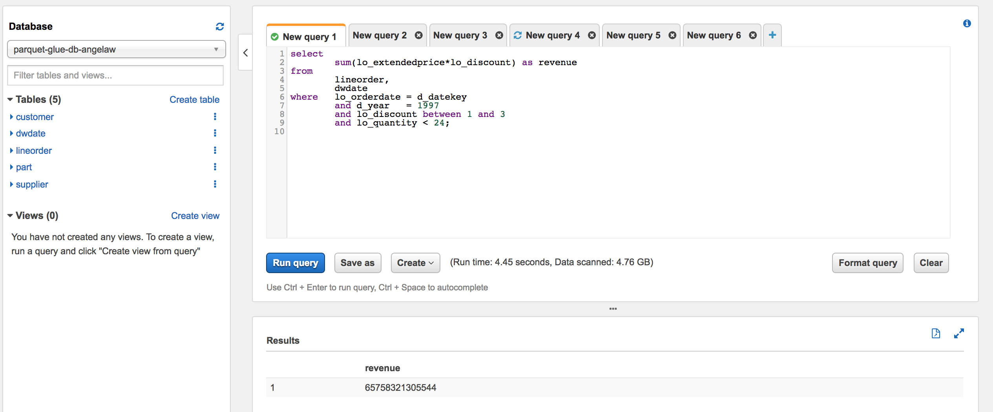

-- Query 2

-- Restrictions on two dimensions

select

sum(lo_revenue),

d_year ,

p_brand1

from

lineorder,

dwdate ,

part ,

supplier

where lo_orderdate = d_datekey

and lo_partkey = p_partkey

and lo_suppkey = s_suppkey

and p_category = 'MFGR#12'

and s_region = 'AMERICA'

group by

d_year,

p_brand1

order by

d_year,

p_brand1;

**Run time: 13.56 seconds, Data scanned: 8.88GB**

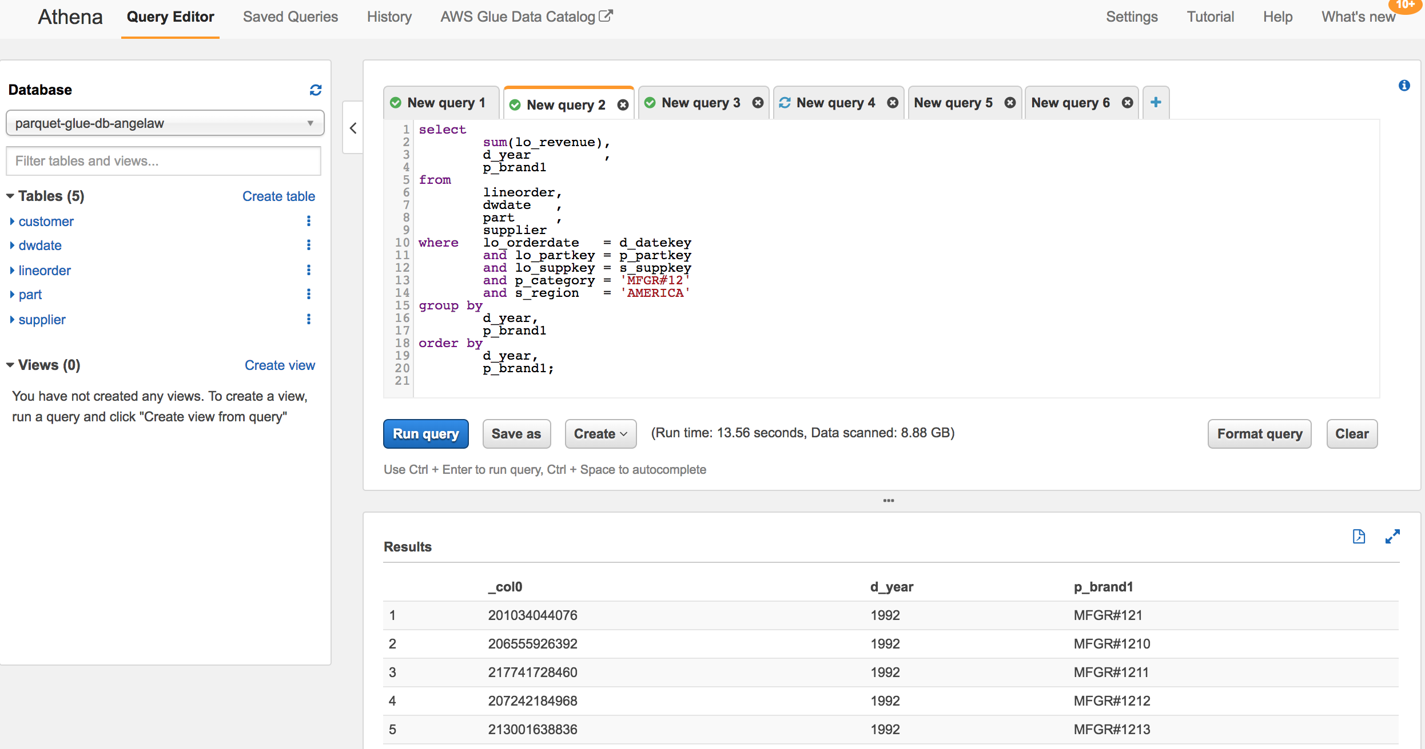

-- Query 3

-- Drill down in time to just one month

select

c_city,

s_city,

d_year,

sum(lo_revenue) as revenue

from

customer ,

lineorder,

supplier ,

dwdate

where lo_custkey = c_custkey

and lo_suppkey = s_suppkey

and lo_orderdate = d_datekey

and

(c_city ='UNITED KI1'

or c_city='UNITED KI5')

and

(s_city ='UNITED KI1'

or s_city='UNITED KI5')

and d_yearmonth = 'Dec1997'

group by

c_city,

s_city,

d_year

order by

d_year asc,

revenue desc;

**Run time: 9.41 seconds, Data scanned: 8.95GB**

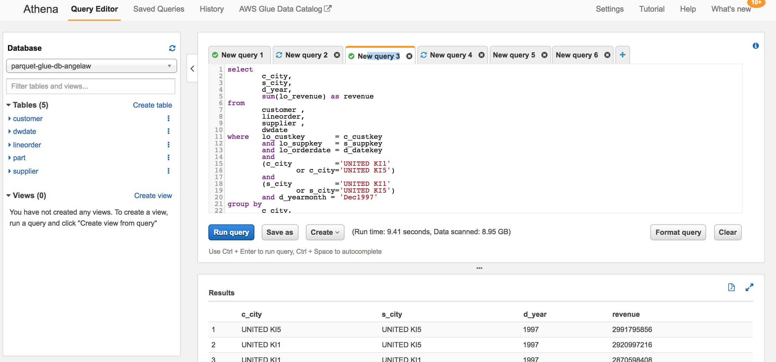

***Note***

*While a query is running in Athena, you can run another query by clicking on the New Query button. The current query will continue to run in the background. You can check the status of all queries in the History Tab. You can also kick off all the three queries above in parallel from three different query tabs.*

# Athena Query Runtime Comparison for CSV and Parquet

|  |  |  |  |  |
| --- | --- | --- | --- | --- |
|  | **CSV and gzip** | | **Parquet and Snappy** | |
| **Query #** | **Run Time**  **(in Seconds)** | **Data Scanned (in GB)** | **Run Time**  **(in Seconds)** | **Data Scanned**  **(in GB)** |
| Query 1 | 133 | 25.12 | 4.45 | 4.76 |
| Query 2 | 171 | 25.18 | 10.36 | 8.88 |
| Query 3 | 174 | 25.25 | 9.41 | 8.92 |

# Amazon QuickSight

[Amazon QuickSight](https://aws.amazon.com/quicksight/) is a fast, cloud-powered BI service that makes it easy to build visualizations, perform ad-hoc analysis, and quickly get business insights from your data. Using our cloud-based service you can easily connect to your data, perform advanced analysis, and create stunning visualizations and rich dashboards that can be accessed from any browser or mobile device.

QuickSight is the first BI service to offer pay-per-session pricing, making it even more cost-effective for you to provide access to analytics and insights for all of your users. With pay-per-session pricing there are no upfront costs, no annual commitments, and no charges for inactive users.

Here are two quick few minutes demo

<https://vimeo.com/267303553>

<https://vimeo.com/267303463>

## Visualizing using QuickSight

Assumption is that you already have a QuickSight user account enabled using an IAM user and followed the instructions [here](https://docs.aws.amazon.com/quicksight/latest/user/managing-permissions.html) to enable necessary permissions.

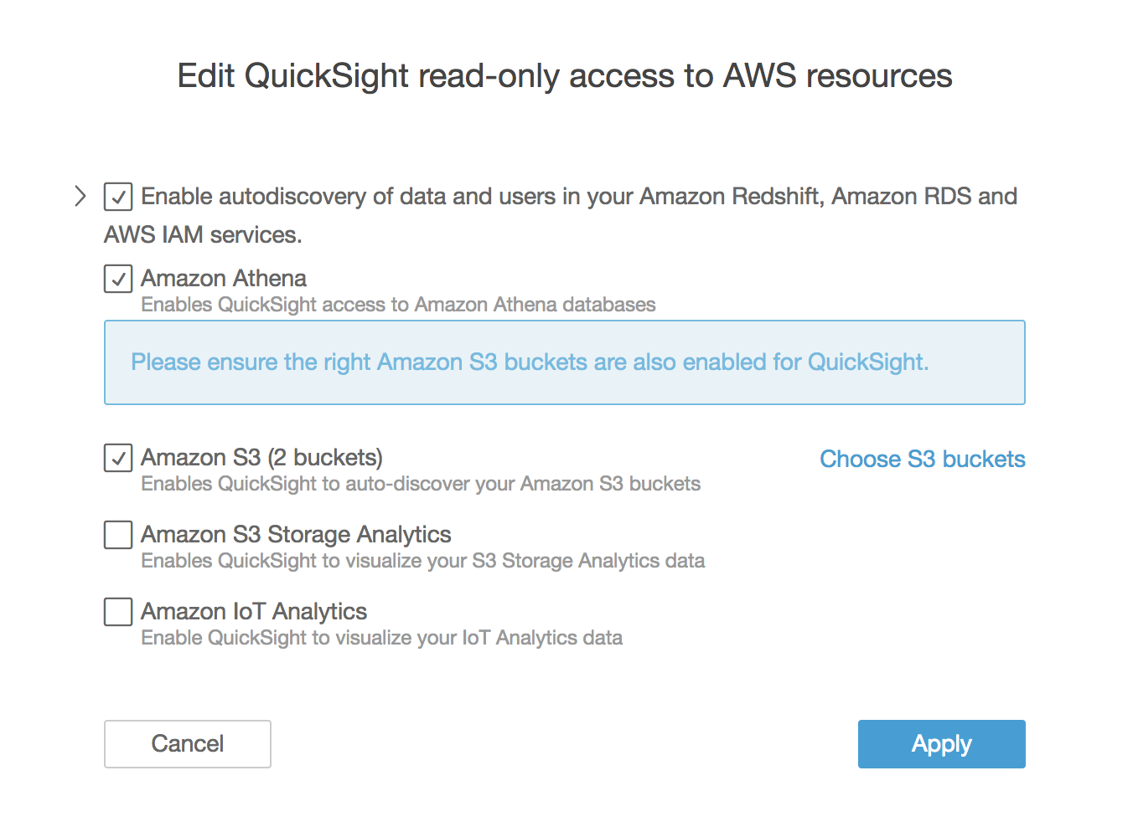

Once the necessary permissions are in place, verify the region matches the same region as Athena and then click on “Manage data” to set up a new data set.

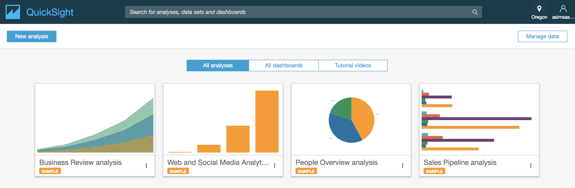

Click on “New data set” and choose “Athena”

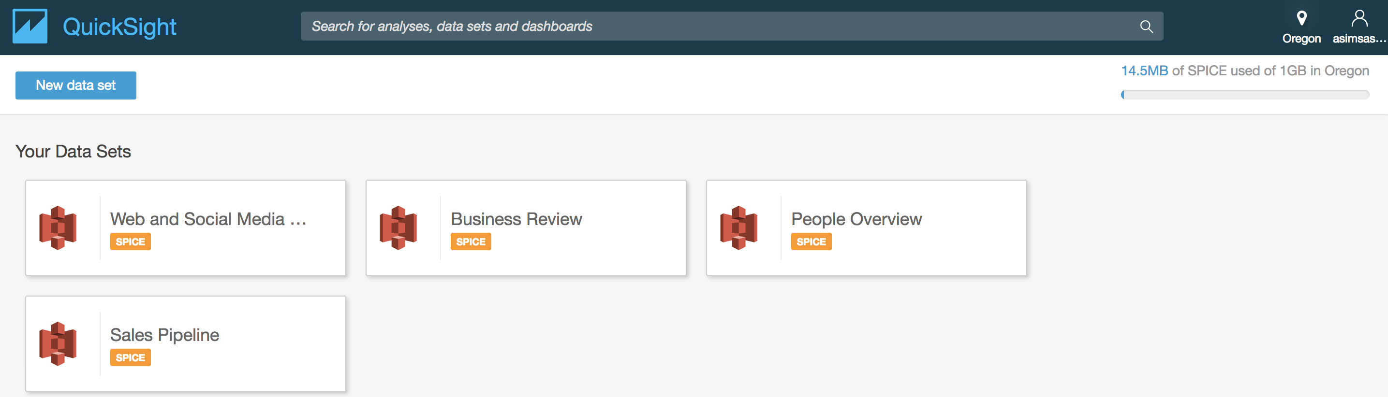

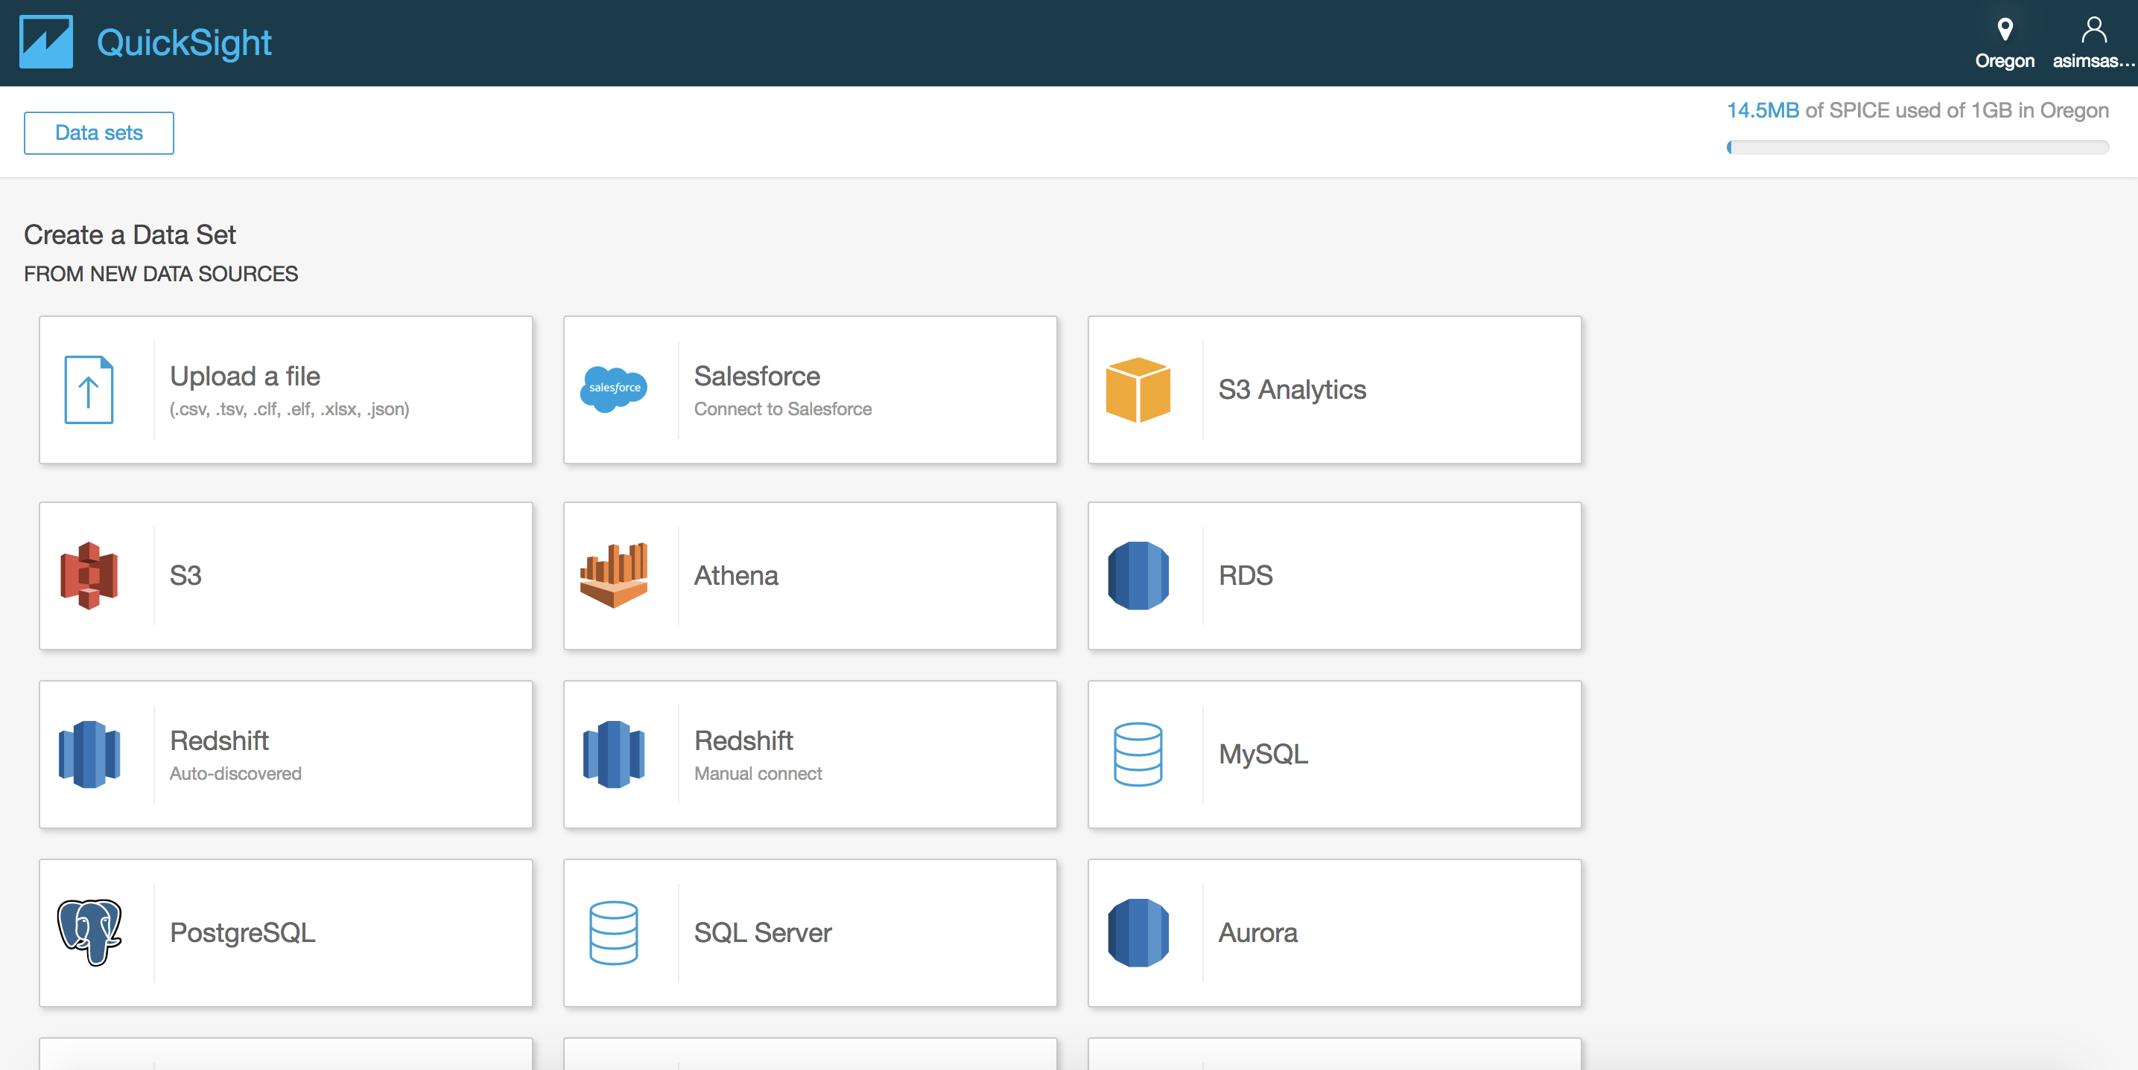

Type “Data source name” as “SSB-parquet” and click on “Validate connection” to make sure that QuickSight can reach out to Athena resources.

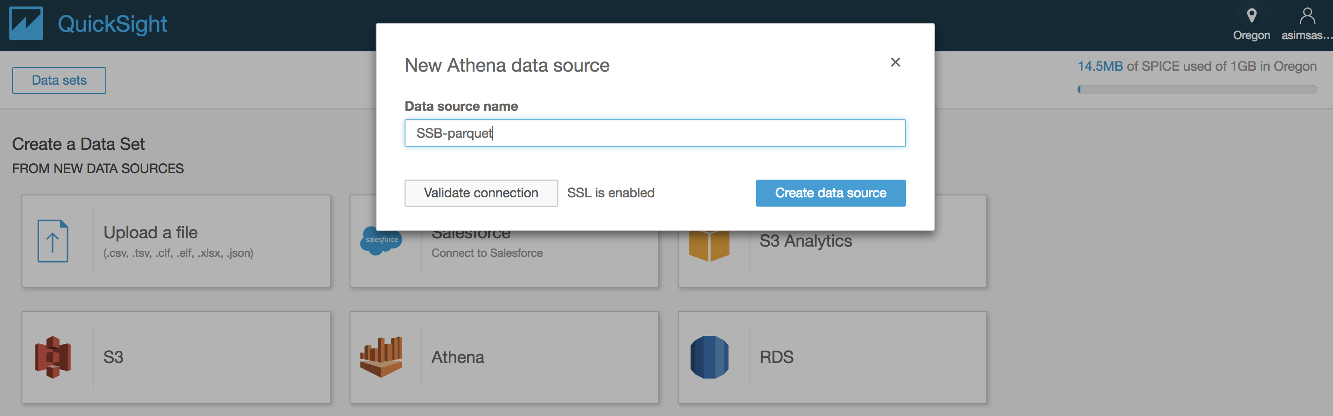

Once you get the “Validated” message, click on “Create data source” to choose the Glue catalog database from the drop down as “parquet-glue-db-<initials-suffix>”.

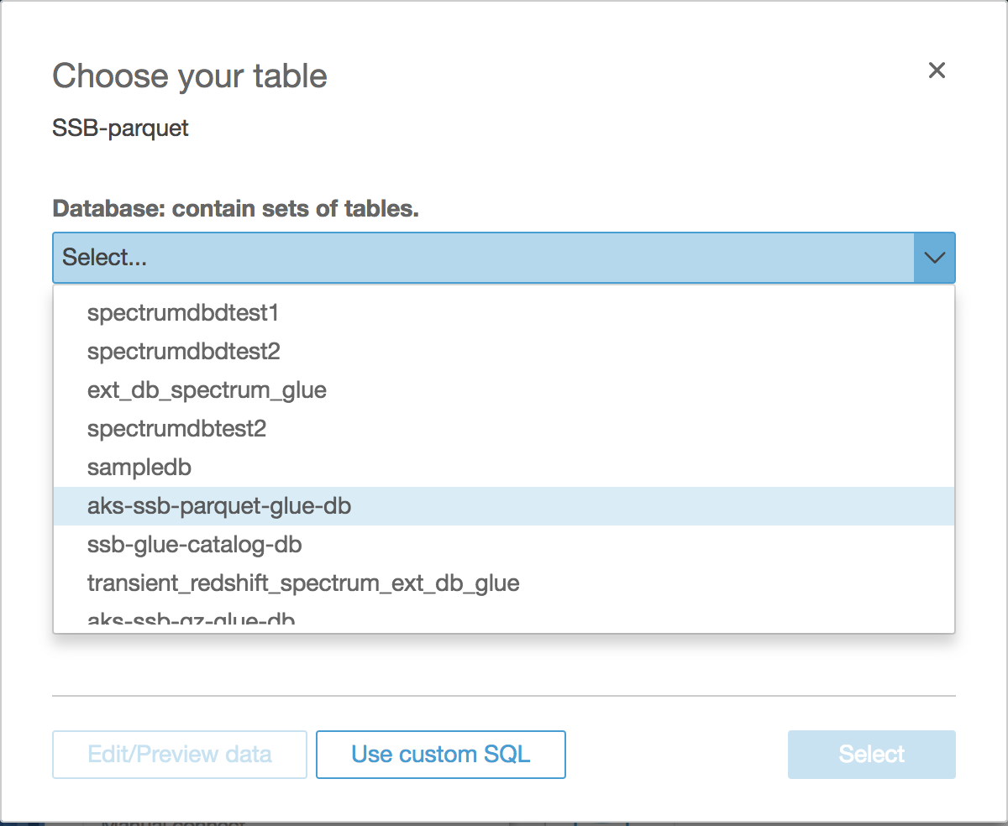

Once database is selected, choose table as “dwdate” and click on “Edit/Preview data” to get to the preview page.

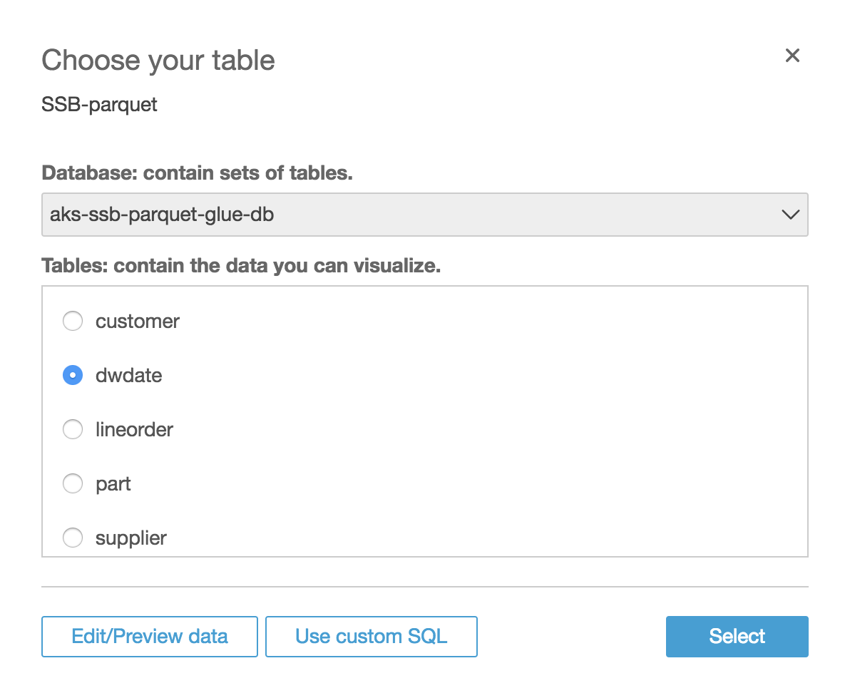

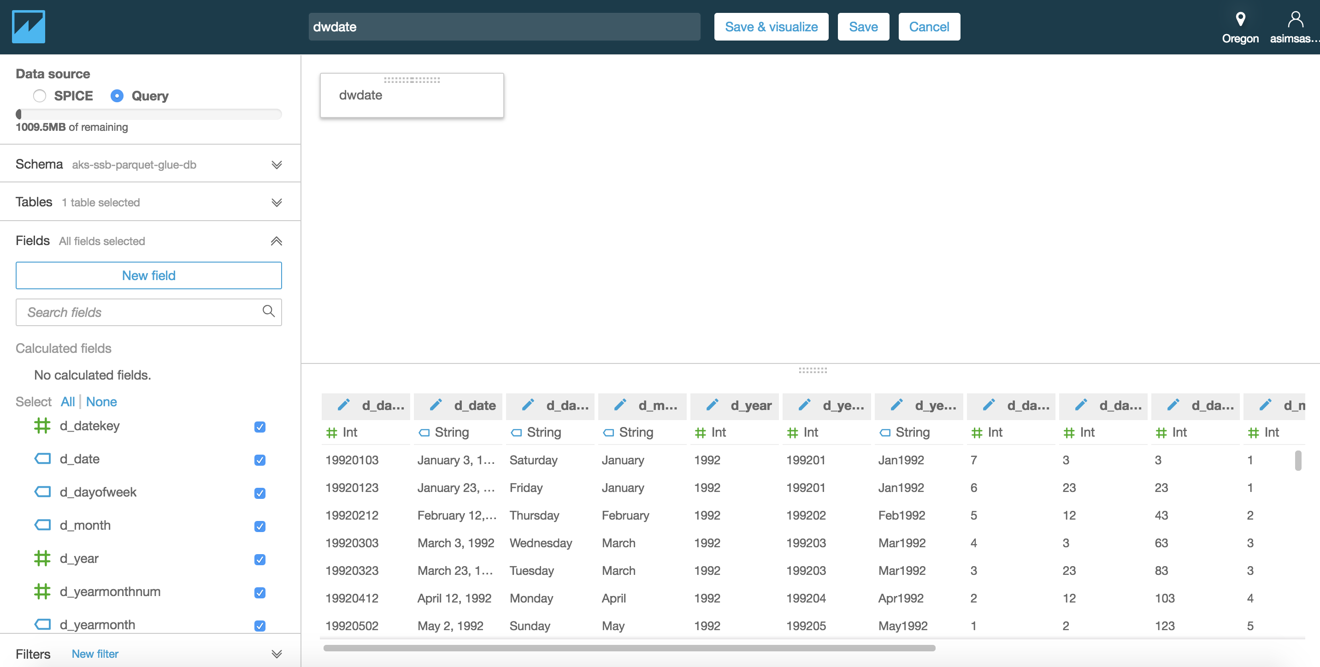

Let’s add a new calculated field called “month_dayofweek” by concatenating “d_month” and “d_dayofweek” as below.

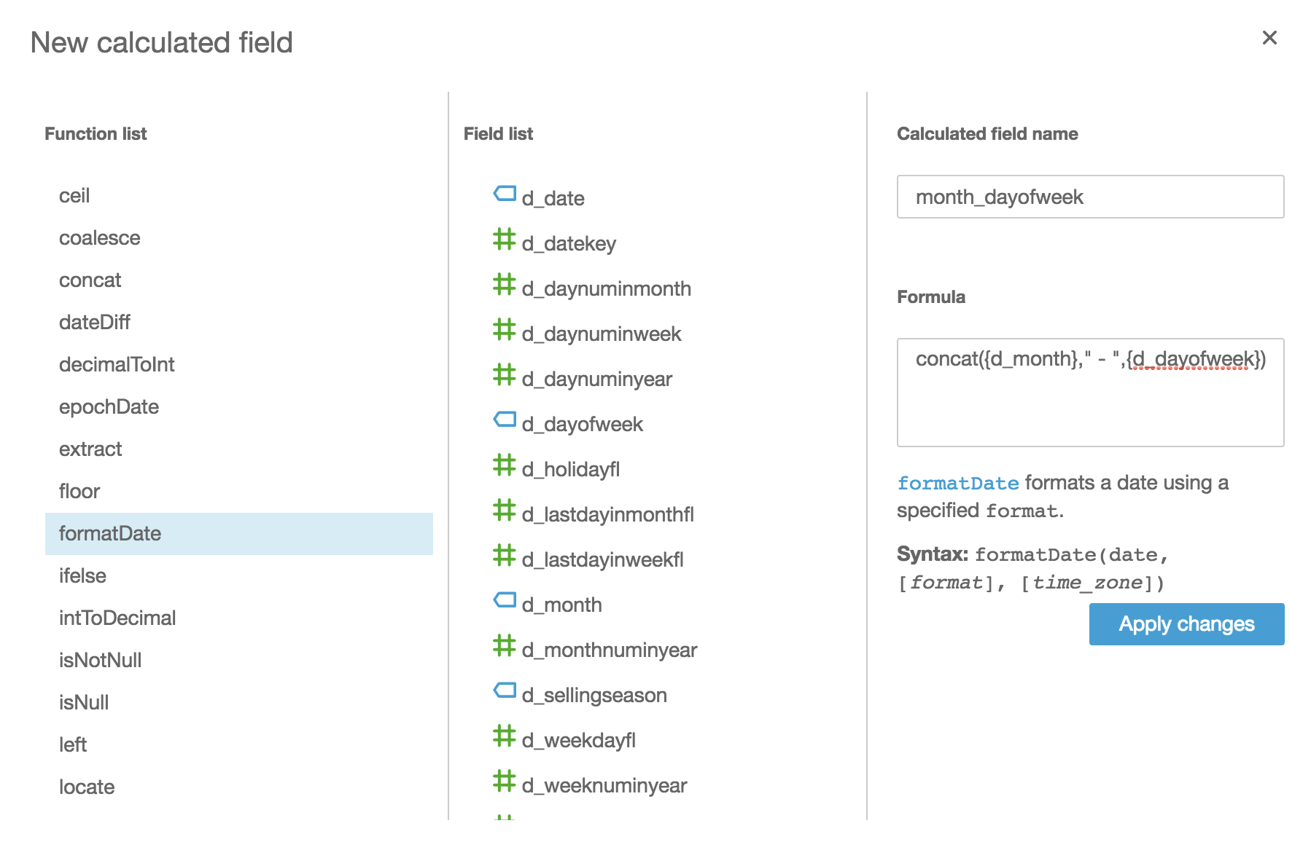

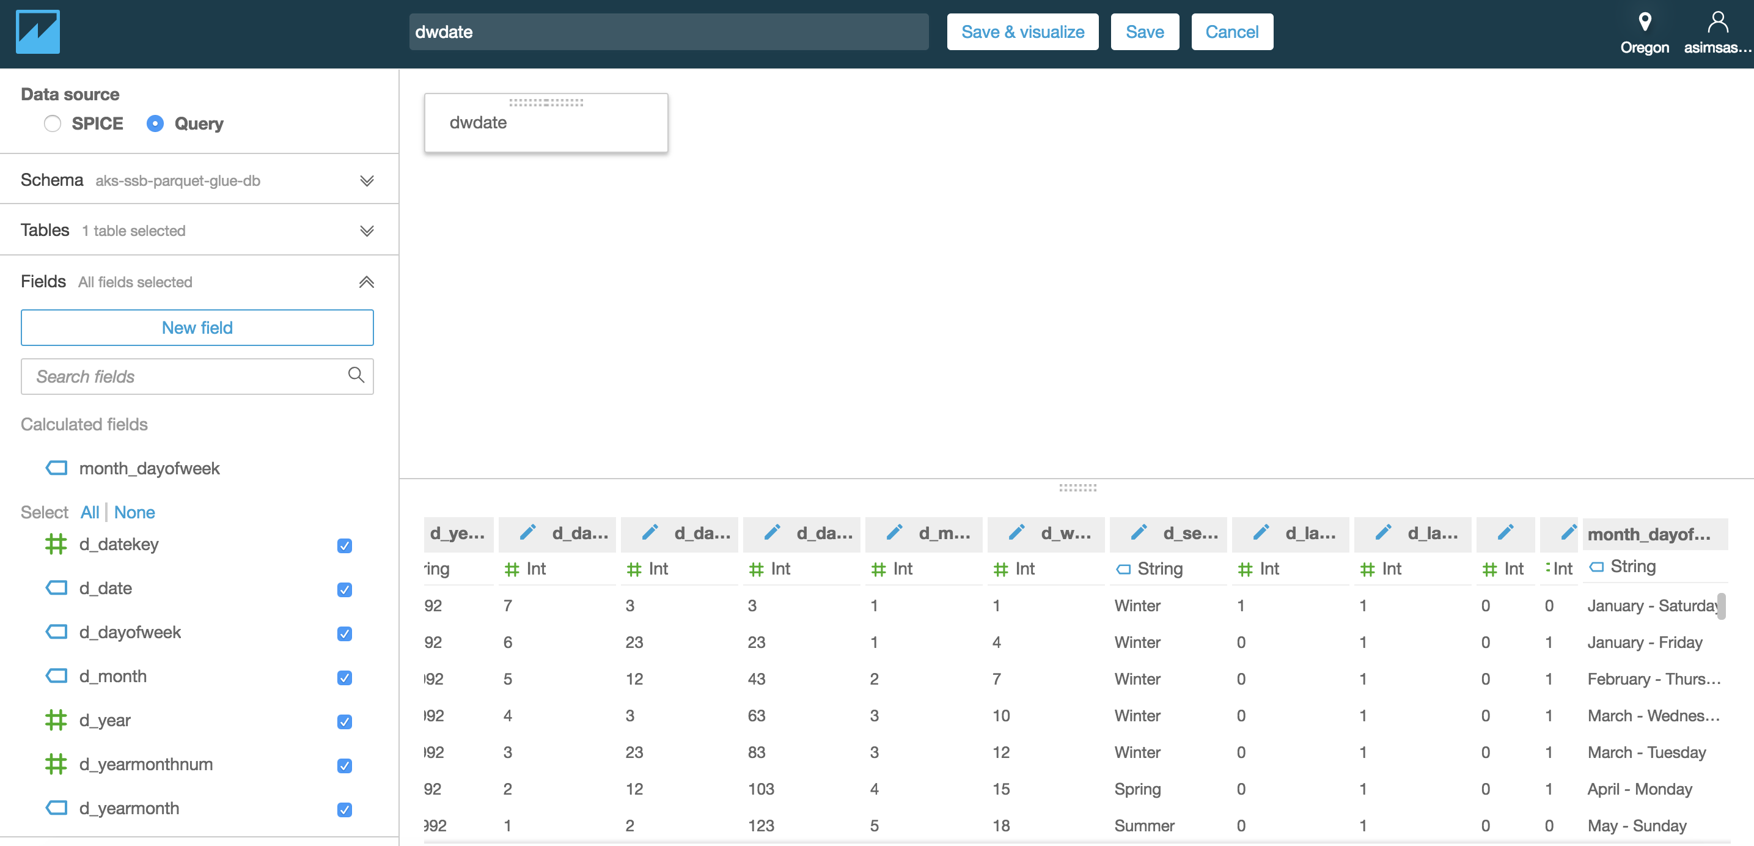

Click on “Save & visualize” and choose the new calculated field created above to visualize total counts by “month_dayofweek”.

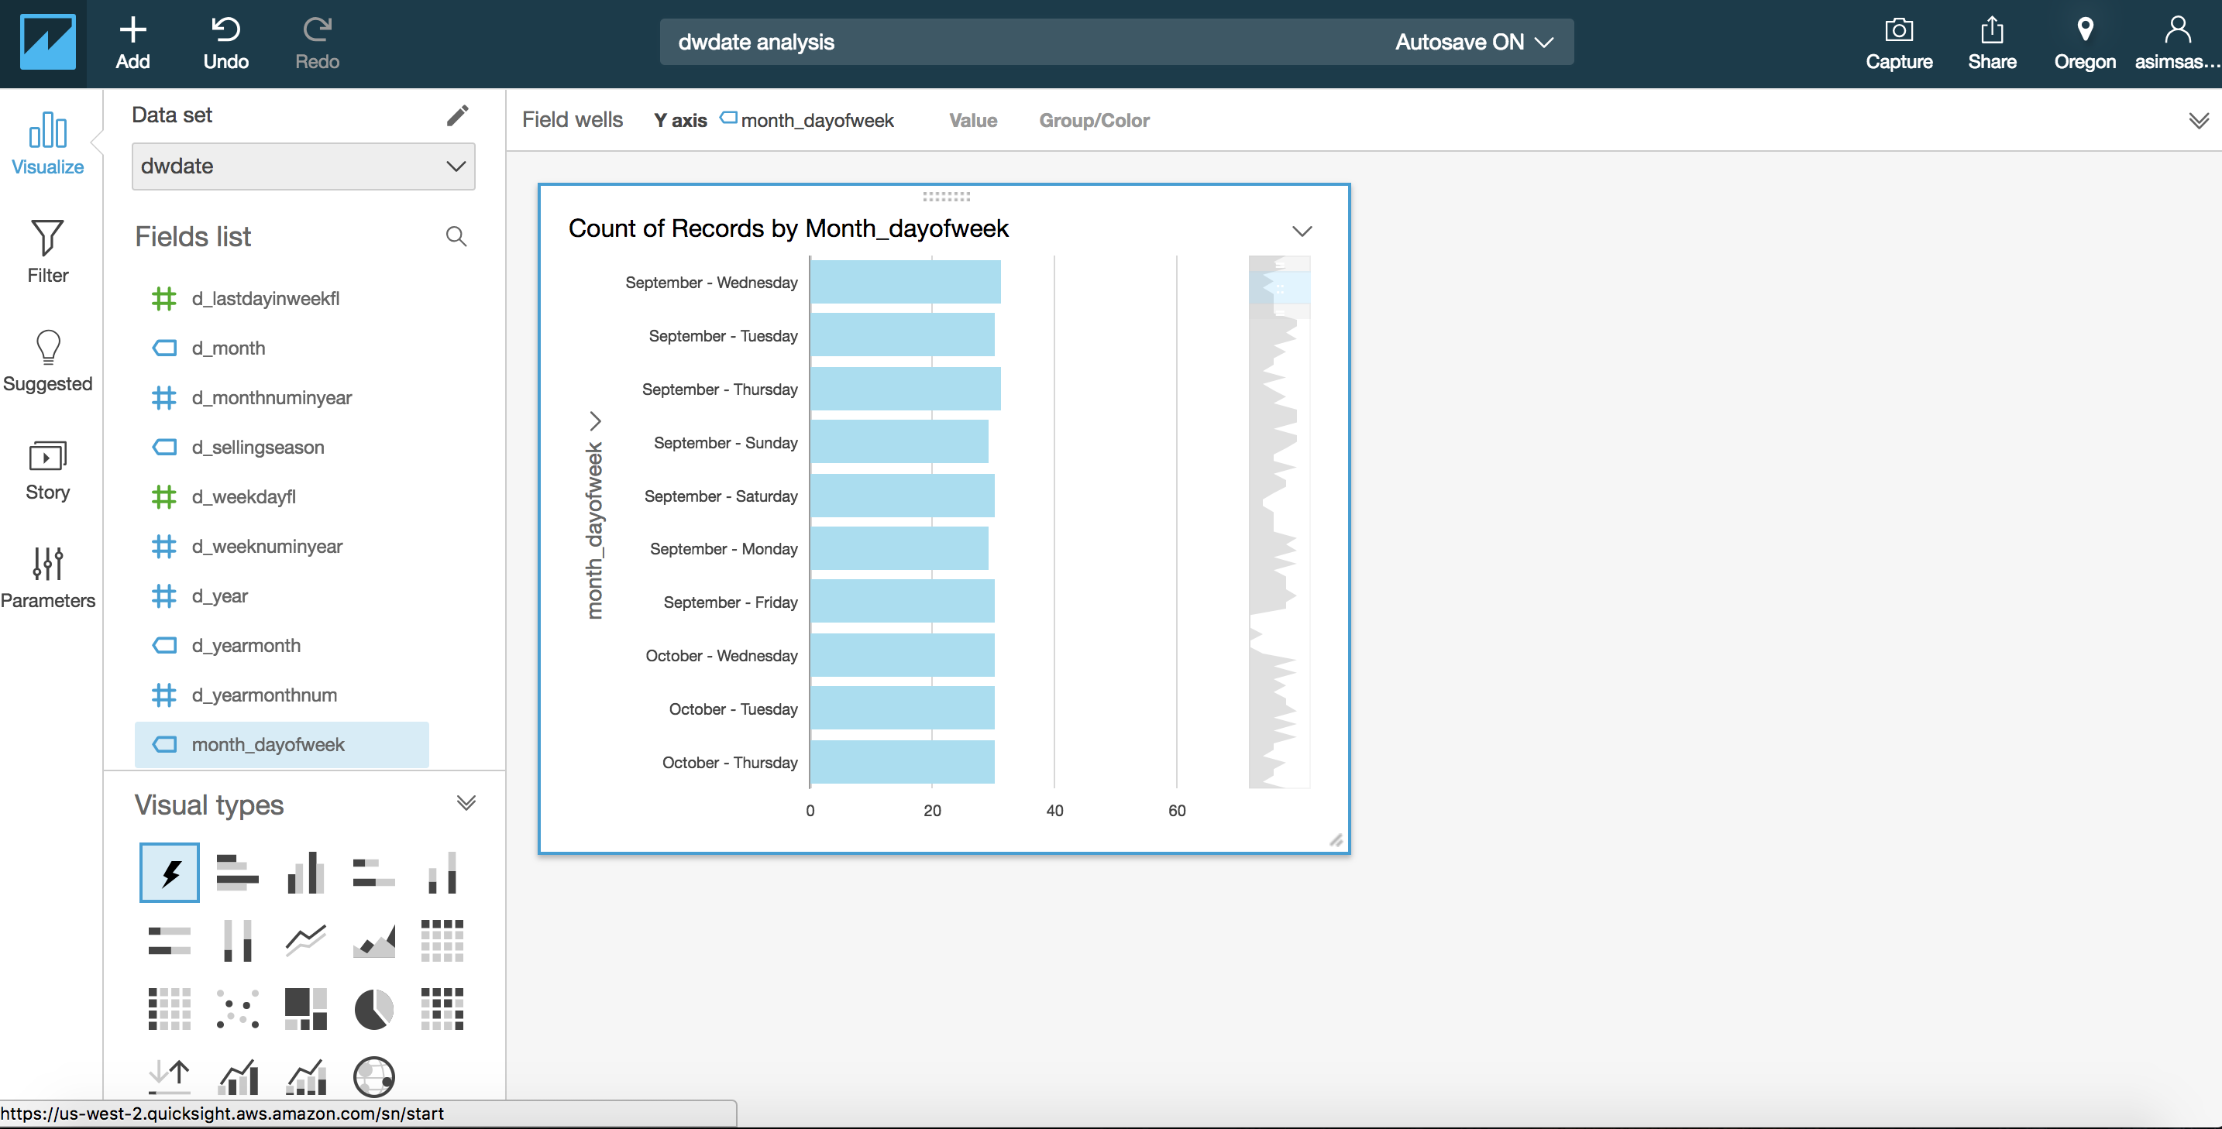

You can also deselect the new calculated field and choose “d_month” to get the counts by that.

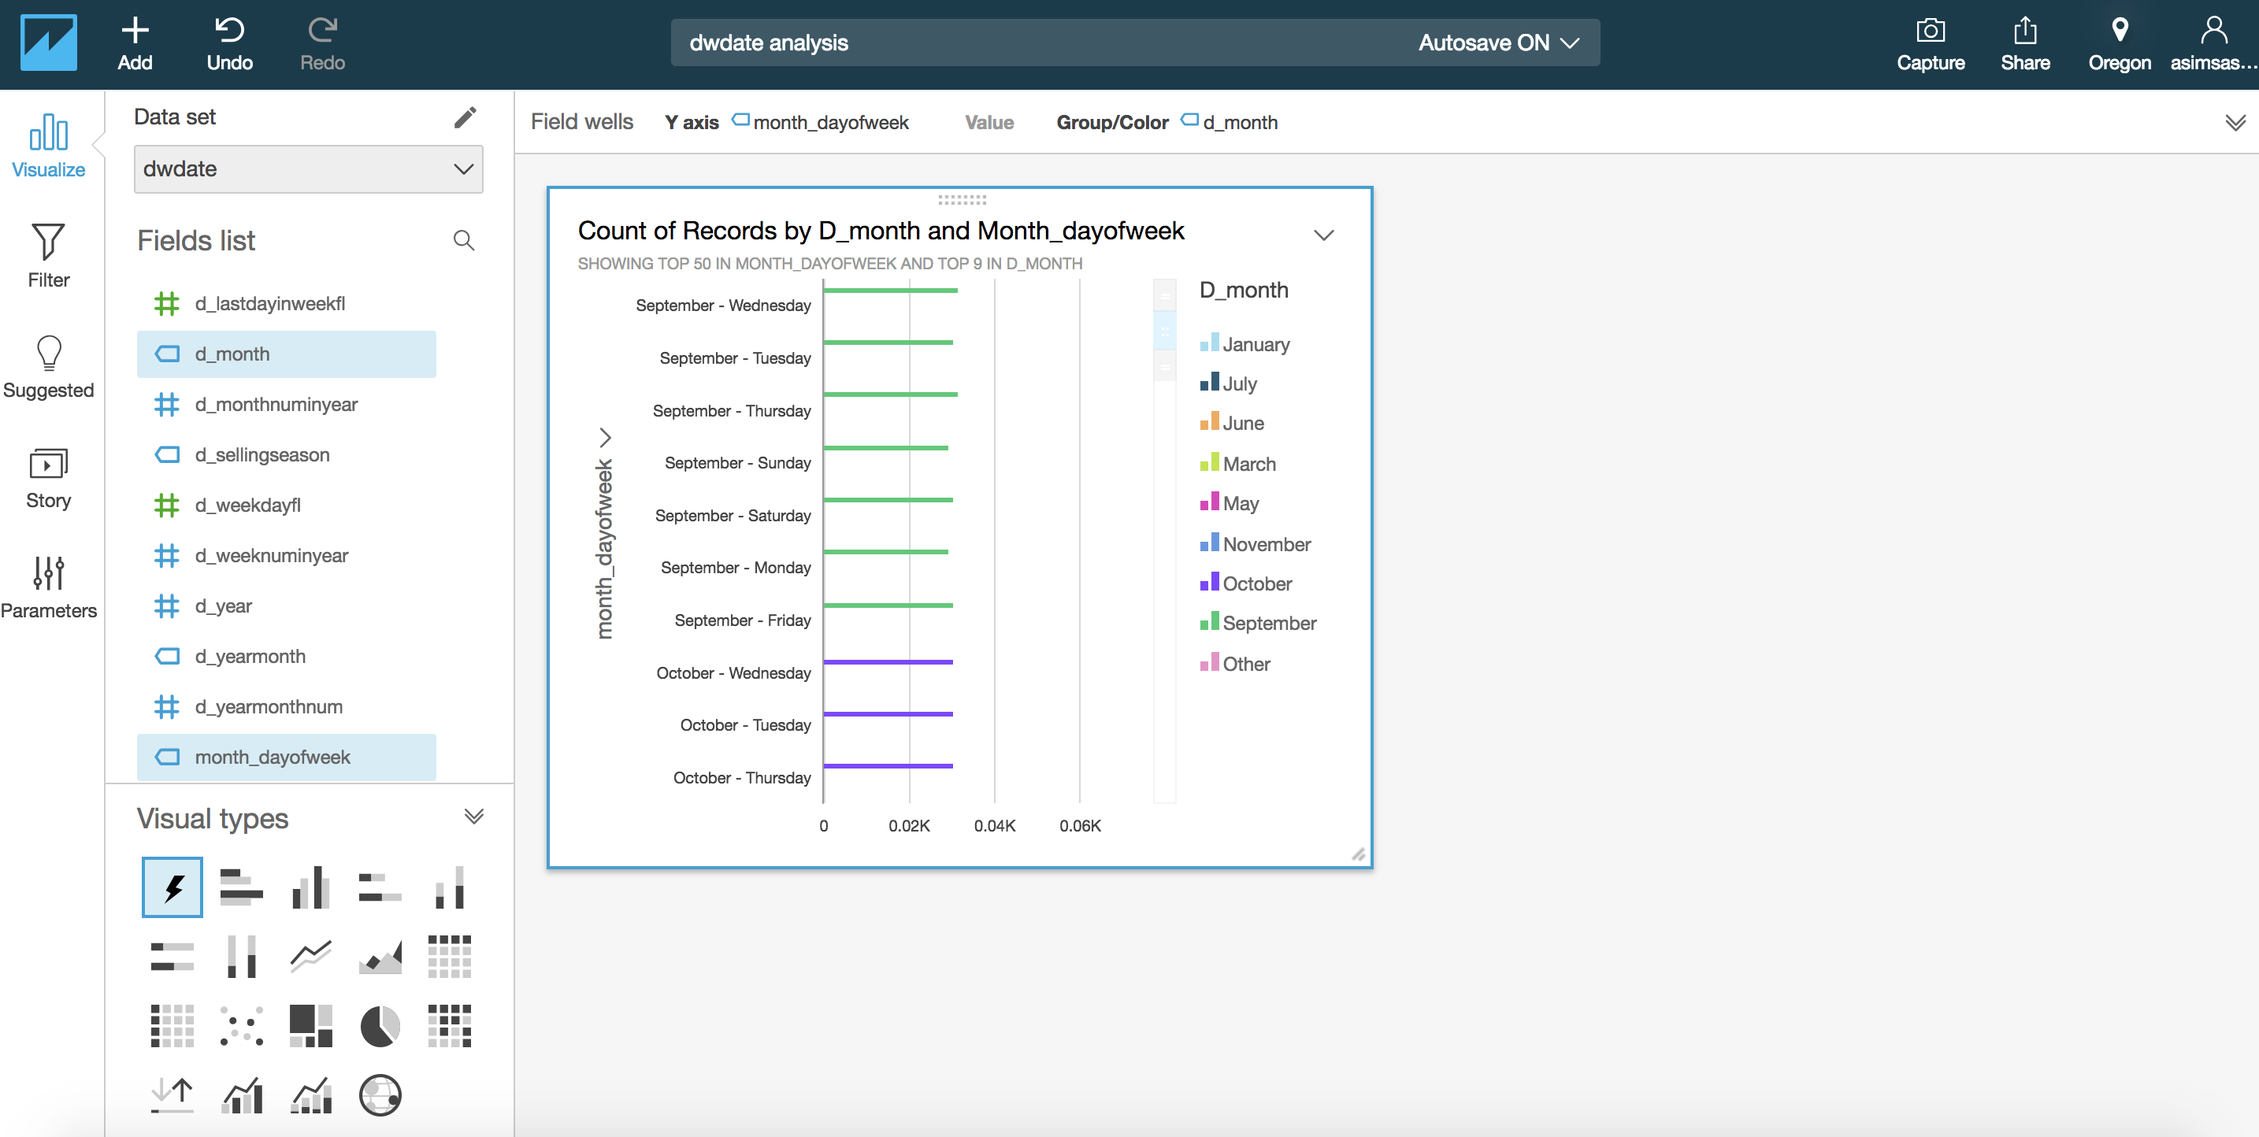

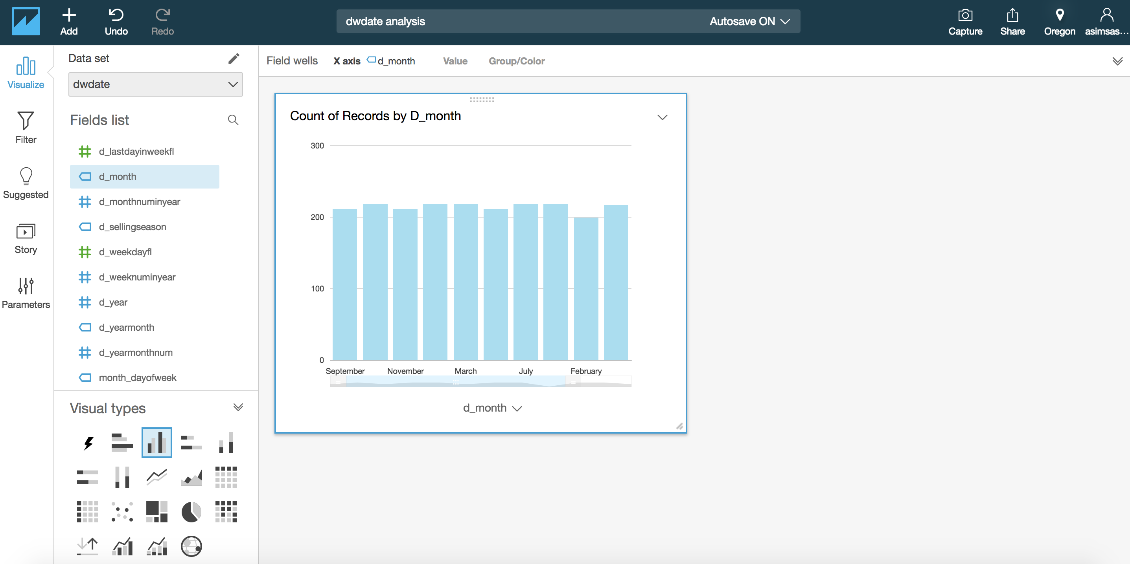

You can change the “Visual types” as “Vertical bar chart” if preferred etc.

# Summary

In this foundation lab, you have gone through a hands-on exercise starting from data discovery to analyzing and visualizing for publicly available AWS sample dataset. You didn’t know the data structure until Glue crawler helped you to find the same and define a proper schema for downstream consumptions. Additionally, for optimal performance of Athena, you have also converted the same dataset from CSV to parquet file format using Glue ETL.